Community-Based Complaints Mechanisms for SHEA and Safeguarding during COVID-19

Developed by the Global SHEA and Safeguarding Team, June 2020

Contents
1. Background on SHEA and Safeguarding complaints mechanisms and COVID-19 3
2. Key Messages 3
3. Types of Complaints Mechanisms 4
4. Principles for community-based complaints mechanisms 7
5. Inclusive Complaints Mechanisms 8
6. Key Stages in Developing Complaints Mechanisms 9
7. Developing child friendly complaints mechanisms 12
8. Complaints Mechanisms for Young People during COVID-19 16
9. Developing complaints mechanisms for communities for reporting sexual exploitation and abuse 17
10. Community Complaints Mechanisms as part of AA’s Humanitarian Response 19
11. Communicating about Community-based Complaints Mechanisms during COVID- 19 20
Annex A: ActionAid Covid-19 complaints response mechanism guidance note 22
Annex B Further Reading 31

Note: Specific content relating to COVID 19 is highlighted in green in the text

Background on SHEA and Safeguarding complaints mechanisms and COVID-19
One of the core principles of ActionAid’s response to COVID-19 is that staff/representatives do not carry out any form of sexual harassment, exploitation, or abuse – or any other kinds of harm- towards the rights-holders and communities we come into contact with during our COIVD-19 response.
As part of our commitment to ‘Do No Harm’ ActionAid must put in place a variety of safer programming measures to ensure our processes do not cause harm and we are accountable to the communities we work with. One example of a safer programming activity is community-based complaints mechanisms.
Community-based complaints mechanisms ensure that communities can raise concerns about ActionAid staff/processes. Communities can use community complaints mechanisms to raise concerns, give feedback to international agencies, and report incidents of sexual exploitation and abuse. They help to create a strong culture of accountability; enable us to improve the quality, impact and effectiveness of our programmes; and ensure our programmes are safe during COVID-19.
During this time community-based complaints mechanisms will need to be established or modified to ensure that communities can raise concerns and are not put at risk of contracting COVID 19 while doing so.
This document outlines key considerations when developing or modifying community based complaints mechanisms during COVID 19, with a focus on how to ensure children, young people and communities can raise concerns about sexual exploitation and abuse and wider child abuse.

Key Messages
- Communities, including children and young people, must be involved in the creation and implementation of community-based complaints mechanisms
- It is best practice to have a range of options for people to report concerns (e.g an option to report anonymously through an SMS hotline, and a place to report to a designated individual).
- All complaints mechanisms must be established under the principle of ‘do no harm’. They must be safe and accessible to use, ensure confidentiality, and not put people at risk of harm. During COVID 19, this includes ensuring that complaints mechanisms do not put people at risk of contracting COVID 19.
- Complaints mechanisms must be inclusive and ensure that diverse groups can safely access the mechanisms and are not excluded from these processes (for example, ensuring people with disabilities can raise concerns).
- Awareness raising activities must inform communities of the complaint’s mechanisms available, their right to report, and emphasize that aid is free.
- Child friendly community-based complaints mechanisms should be established, and we must work with children and young people to develop these.
- When engaging children in the set-up of the child friendly mechanisms, it is important that government directives are adhered to so that we curb the spread of COVID-19. The same applies when engaging communities in the setup of community-based complaints mechanisms for sexual exploitation and abuse.
- Many people prefer to report to someone they know and trust. Staff/partners, particularly those in frontline roles, must be trained on SHEA and Safeguarding and how to receive disclosures.
- Complaints mechanisms should be managed by staff who have received training so they are able to address complaints in a timely way and ensure support to all involved.
- All survivors will be supported and listened to. ActionAid will respond to all complaints and work with survivors to take action.
Best Practice Example

During the Cyclone Idai response in Mozambique, the World Food Programme established a complaints mechanism called “Linha Verde” which recognised the diverse linguistic needs of Mozambique, where 14 languages are spoken and where 37% of the population cannot read. Information was displayed using graphics and images at all response sites to be accessible to many, and encourage reporting.

Types of Complaints Mechanisms
Community Complaints Boxes | These are physical boxes where people can provide written feedback.  - Complaints boxes are relatively inexpensive and are effective in places where there is limited internet connectivity and cell phone range.  - Complaints can be anonymous, as people do not have to include their personal details.  - Complaints boxes are only accessible to people who can read and write.  - Complaints boxes can expose communities to risk as they do not enable fast responses and could delay providing support to survivors.  - Complaints boxes alone are not recommended for sexual exploitation and abuse concerns as they are not accessible to all, and safety and confidentiality are not guaranteed (for example, people may be seen putting a complaint in a box which may put them at risk of stigma or harm from their community, or from AA staff).  General guidance for use of complaints mechanisms:  - Instructions on complaints boxes must be simple, and easily adaptable to local languages.  - Complaints boxes must be accompanied by clear information on how complaints are processed and handled (for example, information about when the boxes are checked and who checks them)  - Complaints boxes may contain sensitive data of survivors and so processes must ensure confidentiality and be compliant with data protection regulations.  - There must be agreement with the community on where to place the box since there is heightened risk of contracting COVID 19. Infectious Disease Prevention Protocols must be in place to ensure that pens and paper are sanitised before community members use them to put complaints into complaints boxes. Masks, gloves, soap and alcohol-based gels should be available where complaints boxes are placed.
SMS and Hotlines | SMS and hotlines enable communities to raise concerns via SMS, texts or phone calls.  - Feedback can be instantaneous so there is no delay (which can be distressing for complainants).  - Two-way feedback is provided, and organisations can respond immediately  - This can be more confidential as wider community members are less likely to be aware that someone has raised a complaint (compared to someone putting a complaint in a complaints box)  - During COVID 19, hotline and SMS services are useful as complaints can be shared in safe and hygienic way  - Community members and rights holders require access to phones, networks and electricity  - This system is only accessible to people who can read and write, and are familiar with different technologies  - This is only accessible to people who have phones and so is not available to everyone.  General guidance for using SMS, hotline and phone systems:  - Staff should consider whether local communities have access to telecommunications infrastructure.  - Staff should consider putting in place an automated system (e.g voicemail responses) and put structures in place so that all complaints are responded to swiftly.  - Sensitive data will be shared in this mechanism which must be managed confidentially and in line with data protection standards. Data received can be useful sources of information on trends in the community, particularly on sexual exploitation and abuse, but must be managed carefully.
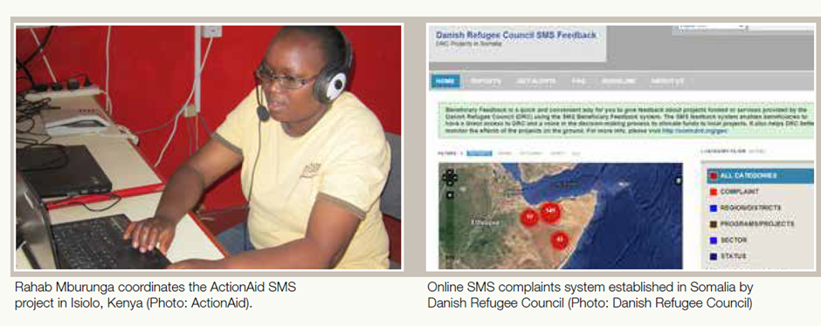
No phone, No dial chat, Low Technology Options | These options allow survivors to report abuse and exploitation offline. Due to economic constraints, survivors may not have access to a phone or technology to raise a concern. This allows survivors who don’t have access to technology to raise complaints.
Helpdesks | Helpdesks enable communities to raise concerns in person to designated and trained individuals. Helpdesks are often operated by communities through volunteers, with the support of staff.  - Helpdesks enable communities to raise concerns face to face, this is particularly important when raising concerns about sexual exploitation and abuse.  - Helpdesks are accessible to people who cannot read or write.  - The disadvantage of helpdesks is that they are resource and labour intensive, and require staff and volunteers with special skills in handling disclosures and sensitive information.  - They can provide greater risk to individuals if they do not include measures to ensure confidentiality
Interagency complaints mechanisms | An inter-agency referral system should be in place in areas where lots of agencies are operating, so that communities can easily raise concerns about any organisation and organisations can then work together to address concerns. This helps to strengthen collective accountability to communities.

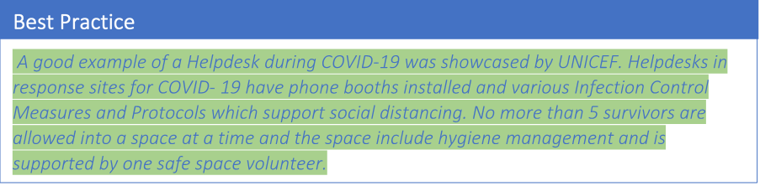

Principles for community-based complaints mechanisms
- Community-based complaints mechanisms are always rooted in community input. Agencies must ensure consultation with communities on the design and maintenance of community-based complaints mechanisms. Special attention must be given to engaging communities safely in the design and development of complaints mechanisms during COVID 19.
- Community-based complaints mechanisms should be established in coordination with local child protection actors and local PSEA networks.
- Community-based complaints mechanisms must be culturally and gender sensitive, and inclusive to ensure no one is prevented from raising a concern. For example, available in local languages and accessible to those who are most marginalised (e.g. people with disabilities).
- Community-based complaints mechanisms should be established in such a way to prevent harm or retaliation towards community members who report concerns.
- Community-based complaints mechanisms must recognise the additional barriers to reporting allegations of sexual exploitation and abuse, child abuse and abuse of adults at-risk, and ensure that all complaints mechanisms are confidential.
- Community-based complaints mechanisms must indicate that survivors will be respected and supported.
- Community- based complaints mechanisms indicate that all aid is free and will be provided in a way that respects the safety and dignity of community members.
- Awareness raising activities must be undertaken with communities to inform them of their right to report concerns, the different complaints mechanisms available and how organisations manage reports. Sessions should include discussions about sexual violence and the value of reporting to help challenge social norms and reduce stigma.
- All community-based complaints mechanisms must be safe for communities to use during COVID 19 and should adhere to regulations on social distancing and other hygiene measures.
Best Practice

In the Democratic Republic of Congo, the Congo Pilot Project of Save the Children saw 41 complaints of Sexual Exploitation and Abuse raised over a period of 8 months. These complaints included historical concerns which indicates that communities were made more aware of their rights and felt safer to access the community-based complaints mechanism.

Inclusive Complaints Mechanisms
At ActionAid, we are committed to amplifying the voice and agency of marginalised and oppressed communities. As part of this, we must ensure that community-based complaints mechanisms are inclusive and enable anyone to raise a concern.
- A variety of mechanisms and channels must be available for communities including suggestion boxes, hotlines, no dial chats, SMS systems and help desks. During COVID 19, helpdesks are to adhere to social distancing and health regulations. It is critical that communities have a variety of ways of reporting, as this helps to ensure that people from diverse groups have options which are more tailored to their needs.
- Community-based complaints mechanisms must be accessible to groups that are traditionally marginalised (for example, people with disabilities, people from minority ethnic groups, older people, people from the LGBTQI community). These groups must be consulted when creating complaints mechanisms, their needs and views must be integrated into the design of mechanisms, and specific mechanisms should be developed for them.
- Community-based complaints mechanisms are developed for people with diverse literacy capabilities and recognise different social contexts (e.g. non-written options for communities where writing is not the main form of communication).
- SHEA and Safeguarding Focal Points must work with relevant teams to ensure that any community-based complaints mechanisms are accessible, inclusive, survivor-centred, and relevant to the local context (e.g. to ensure that people with disabilities are able to access complaints mechanisms).
- Staff managing complaints procedures must be trained to ensure they have the skills and competencies to take complaints of abuse and exploitation from at risk groups and that they do this with sensitivity and care, and do not bring any bias or prejudice to those interactions.
- Staff should work in a participatory way with children and young people to build community-based complaints mechanisms that are safe and accessible for them to use. Children and young people must have a voice in how safe spaces are created.
- Awareness raising activities must be carried out to people from marginalised or excluded groups to ensure they are aware of their right to report concerns, and reminded of what behaviour is and is not appropriate from AA staff and partners.
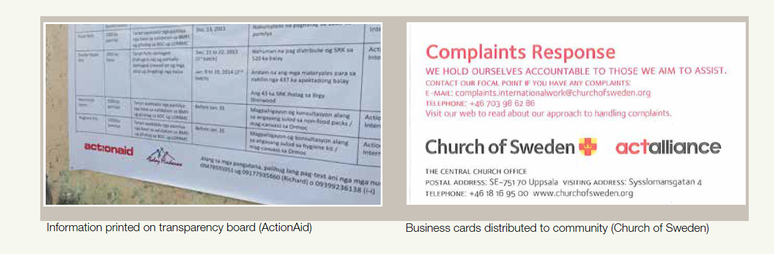

Key Stages in Developing Complaints Mechanisms
The following points should be considered in developing community-based complaints mechanisms. They will help ensure that any complaints mechanisms established or modified during ActionAid’s COVID 19 response are safe to use:

Preparedness/needs assessment:
- Gather information on the local environment and existing community engagement and feedback channels.
- Use participatory tools to engage with communities on their needs and what complaints mechanisms are required. Carry out early awareness raising sessions to inform communities on their rights, the role of complaints mechanisms as part of wider accountability measures, and ActionAid’s positive view of complaints and feedback.
- Ensure that any plans to develop complaints mechanisms engage early with wider systems e.g. local justice systems, local government processes.
- Carry out Risk Assessments to ensure that any planned community-based complaints mechanisms would not put individuals at risk of harm and identifies where there is risk of sexual exploitation and abuse taking place. The findings of needs assessments should be shared with the community.
- Staff and partners developing community complaints channels should identify the best possible ways to promote community participation in safe and hygienic ways during the pandemic so that processes do not put anyone at risk of contracting COVID 19.
- Assess referral pathways available e.g. health providers, one stop shops. During COVID 19, ensure that these are still active and accessible as systems may have modified or closed because of the pandemic.

Design:
- Staff developing community-based complaints mechanisms should work closely with partners, and establish a common understanding of the principles of accountability towards communities in the COVID 19 response.
- Staff and partners will work with communities on the design of complaints mechanism. Staff working on complaints mechanisms will identify safe and hygienic ways of facilitating community participation. Effective hygiene management and Infectious Disease Protocols and Measures will be implemented during community participation.
- Staff and partners will engage with external agencies and referral mechanisms and ensure this is built into the design of complaint mechanisms.
- Staff and partners will design case management processes to ensure that any complaints raised through the complaint’s mechanism are handled safely.
- Staff and partners will develop Information, Education and Communication (IEC) materials on the community-based complaints mechanisms; and develop wider awareness raising activities with communities on the mechanisms. Materials on community-based complaints mechanisms should avoid putting communities at risk of infection during COVID-19 (e.g. avoid materials that are shared between people, and instead use materials that can be put up in safe and open spaces).
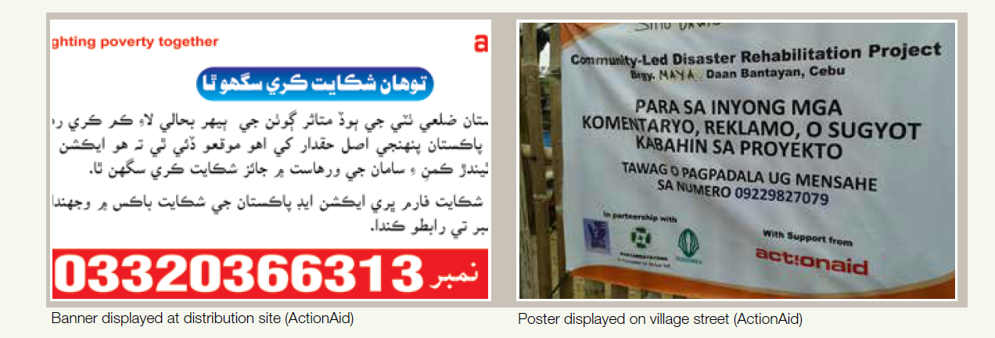

Implementation:
- Complaints mechanisms are embedded and available to be used in all programmes and in all response sites for COVID-19.
- Community-based complaints mechanisms will be monitored regularly by staff and partners. Any approach to monitoring community-based complaints mechanisms will be done in line with safe and hygienic guidance on COVID 19 protection
- Concerns raised will be addressed swiftly, in line with AA’s case management procedures
- Awareness raising activities will take place continually to remind communities of their right to raise concerns. Staff and partners will publicize and disseminate the community-based complaints mechanisms to communities in safe and hygienic ways.

Evaluation/Assessment:
- Community based complaints mechanisms should be regularly reviewed to ensure they are functioning well and remain relevant. During COVID-19, community-based complaints mechanisms, should be reviewed regularly to adapt to the changing nature of the pandemic.
- At the end of a project, the complaints mechanism should be evaluated to see whether it has been successful and useful. Community participation in evaluation is critical.
- Lessons learnt should be documented so that future complaints processes learn from this and are strengthened.
Best Practice

ActionAid Kenya carried out an innovative use of SMS for two-way communication between ActionAid and community relief committees during the 2010 east Africa drought. SMS was used to share information on crop prices, relief distributions and security issues. This kind of platforms can also be used to facilitate complaints channels for sexual exploitation and abuse.

Developing child friendly complaints mechanisms
A child friendly community-based complaints mechanism is a reporting procedure that is accessible to children and enables them to raise concerns. They are created with children and are informed by children’s ideas about their needs. Child friendly complaints mechanisms uphold the rights and voice of children by providing opportunities and platforms for children to be heard.
Child participation and inclusion in the set-up of complaints mechanisms is an important way of ensuring they are relevant to different contexts and children’s needs. All child-friendly complaints mechanisms must be developed in line with the AAI Child Safeguarding Policy and ensure that children are not harmed or negatively impacted in any way.
During the COVID-19 pandemic, restrictions may affect child participation in the set-up of child friendly community-based complaints mechanisms. It is critical to ensure that as far as possible children can still participate in the creation of child friendly community-based complaints mechanisms so that children can continue to make safeguarding reports, provide feedback on quality of services, and obtain information about the pandemic.
Key questions when developing child friendly complaints mechanisms during COVID 19
- How can children who are in closed spaces (e.g. unable to leave their homes due to lockdown) participate in the design of child friendly community-based complaint mechanisms?
- How can children who are in closed spaces access community-based complaints mechanisms under COVID-19?
- How can we enable effective child-friendly mechanisms that adhere to social distancing regulations during COVID? For example, how can we create safe spaces, such as children’s centers, for children to report abuse during COVID/lockdown?
- How can we ensure that community-based complaints mechanisms are inclusive and accessible to all children, with a focus on those who are particularly vulnerable during COVID- 19?
Characteristics of inclusive child friendly community-based complaints mechanisms | - Child friendly community-based complaints mechanisms should be accessible and should appreciate the diversity of various children (e.g. children with disabilities) and ensure equal opportunity of access for all children.  - During development, child friendly community-based complaints mechanisms should also consider the current COVID-19 directives e.g. lock downs and restriction of movement so that they are easily accessible by children without risking their health, including children who may have existing health conditions and could be more at risk.  - Children, particularly those from marginalised or excluded groups, must be involved in the development of child friendly community-based mechanisms.  - Community-based complaints mechanisms for children can be integrated into educational programmes as long as they adhere to government directives for COVID-19.  - Helpdesks or safe spaces should be equipped with visual material that younger children can understand, and toys which create a relaxed environment for children and encourages them to open up and raise concerns. Materials should be available for diverse groups of children. For example, information shared through easy-to-understand images, braille, in sign language etc.
Management of child friendly complaints mechanisms | - Child friendly complaints community-based mechanisms should be managed by staff or partners who are trained to work safely with children. Skills include the ability to interview children, patience, and active listening.  - Child friendly community-based complaints mechanisms should be set up in a conducive environment that guarantees confidentiality. For example, when a child is reporting others should not be able to listen in on the conversation.  - Child friendly community-based complaints mechanisms should uphold the principle of do no harm. The mechanisms should recognize that risks are involved with reporting safeguarding allegations and so mechanisms should be established in a place known to children that is safe for them to access, where confidentiality is assured, and where they are treated with respect and encouraged to freely share their concerns.  - During COVID-19, child friendly community-based complaints mechanisms must be situated in places that do not risk children’s health  - Complaints should be immediately addressed to build trust in complaints mechanisms. Clearly communicate feedback to the child/their family, to strengthen trust in the mechanism.  - Staff handling the complaints mechanisms should clearly and transparently explain to children what can and cannot be done. Children, guardians/parents and the wider community should be informed of the reporting procedures and following process, including the services and support available to them when they access the complaints mechanisms.  - Children should be made aware that AA may need to tell authorities (e.g the Police, local child welfare services) about a concern they raise. If information shared suggests that a child has been harmed or a child's life is in danger, then action will need to be taken to ensure safety of that child. As far as possible, children will be told why the decision has been made to breach confidentiality, and guardians/parents will be safely informed. While confidentiality may need to be breached, only those who need to know will be informed so they can take effective action.  - Staff/partners must build and maintain strong connections with external agencies and support services to ensure safe referrals can be made and joint approaches are established to help protect children.  - Child friendly community-based complaints mechanisms should be periodically reviewed to assess their effectiveness.  - Child friendly community-based complaints mechanisms should consider health risks for children and include facilities for water, hygiene and sanitation.  - When engaging children during the setup of complaints mechanisms, it is important to adhere to the government directives aimed at containing the spread of COVID-19 e.g. social distancing, use of masks, regular washing of hands and sanitization. As much as possible, the views of children may be collected in a manner that minimizes infection risk i.e. using online platforms. Any online spaces must have safeguards in place to avoid causing harm to children. Consent from parents/guardians must be given prior to any engagement with children.
Community-based complaints mechanisms for children must emphasize the following values | - ActionAid will not tolerate its staff/representatives carrying out any form of abuse, harm, exploitation, or neglect.  - ActionAid staff are prohibited from carrying out sexual activity with anyone under the age of 18. This is considered abuse. Mistaken belief in the age of a child is never an excuse.  - ActionAid staff are prohibited from carrying out any form of sexual exploitation (e.g they cannot try to exchange anything with communities for sex or sexual favours)  - ActionAid staff must not physically, sexually, emotionally or verbally abuse any child.  - Children are encouraged to report and can report in the way that is best for them.
Examples of Child Friendly Community Based Complaints Mechanisms to use during COVID-19 | - Engage with local leaders such as chiefs, volunteers and staff and grassroots organisations, who are trained to receive concerns from children, and ensure they are trained on SHEA and Safeguarding.  - Partner with local authorities (e.g the police, child welfare services) to receive and respond to child safeguarding concerns.  - Train project staff to make follow-up phone calls to the most vulnerable children, as a way to also enable children to report safeguarding concerns.  - Catch-up centres which are used by out-of-school children can be used as child friendly spaces where affected children can access help.  - Staff/partners carry out home visits to check on children involved in programmes, and pick up any concerns – where this is safe to do during COVID 19.  - Staff/partners in nomadic communities can visit animal watering points and grazing fields to assess the welfare of children in projects and pick up safeguarding concerns.
of safeguarding and other concerns by the children and community.

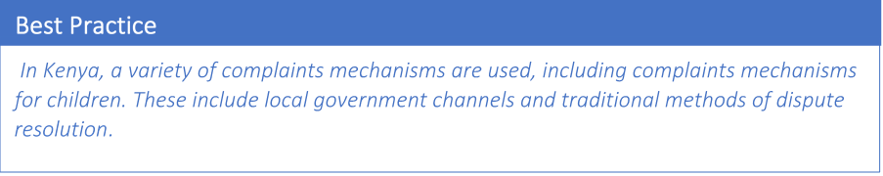

Complaints Mechanisms for Young People during COVID-19
The COVID 19 pandemic raises specific risks to young people (15-24). As young people are a critical part of shifting power dynamics, programmes aimed at and run by young people during COVID 19 must have safeguarding measures to protect them from abuse and exploitation. When developing community-based complaints mechanisms for young people, the following should be considered:
- Complaints mechanisms must be accessible and relevant to young people, recognising their specific risks and needs (for example, materials that are age appropriate, clear but not patronising, and reflect the specific safeguarding experiences that young people may face).
- Young people must have a voice in how safe spaces are created. Staff/partners should work in a participatory way with young people to develop community-based complaints mechanisms that are safe and accessible for them to use, and that are relevant to them and their needs.
- Complaints mechanisms must be designed to take in account the needs of young people from particularly at-risk groups (for example, young people who have disabilities, young activists, young people from the LGBTQI community) and ensure they do not put them at further risk of harm.
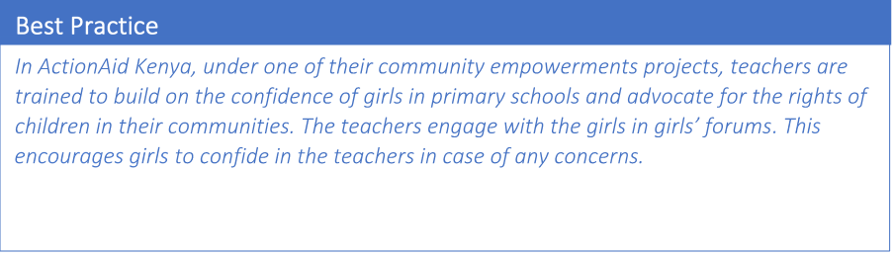

Developing complaints mechanisms for communities for reporting sexual exploitation and abuse
Community-based complaints mechanisms must enable community members to raise concerns about sexual abuse and exploitation. Recognising the particular barriers to reporting sexual exploitation and abuse, complaints mechanisms must be safe to use, survivor centred, and ensure that anyone who reports does not face harm or discrimination for reporting. This will help build trust in AA’s systems, and in our staff and partners. All complaints mechanisms must be developed in line with the AAI Protection from Sexual Exploitation and Abuse (PSEA) Policy and ensure that communities are not harmed or negatively impacted by engagement with AA in any way.
Key questions when developing community-based complaints mechanisms for sexual abuse and exploitation:
- How do survivors in hard to reach areas access community-based complaints mechanisms so they can report sexual abuse and exploitation during COVID-19?
- How can survivors who are in hard to reach areas participate in the design of community-based complaints mechanisms during COVID-19?
- How can we develop survivor centred community-based complaints mechanisms during COVID 19?
- How can we ensure community-based complaints mechanisms are inclusive and accessible to all survivors?

Key considerations when putting in place community complaints mechanisms for sexual exploitation and abuse | - All area of operation include complaints mechanisms  - Consultations on complaints mechanisms are safe and effective and do not expose communities to contracting COVID-19.  - Risk Assessments carried out when designing COVID 19 response programmes include SHEA and Safeguarding, and the creation of community-based complaints mechanisms.  - Communities are aware of SHEA and Safeguarding risks and are involved in the assessment of risks when designing complaints mechanisms.  - A variety of community-based complaints mechanisms are available including hotlines, SMS, no-dial chats and frontline staff who are trained with the right skills to receive complaints.  - There is a simple process outlined for handling complaints in all response sites. All staff and partners are trained on complaints handing in safe and effective ways.  - All staff are aware of the health risks when developing community-based complaints mechanisms under COVID-19 and the importance of adapting these to be safe during this time so they do not pose an infection risk to communities.  - Ensure awareness raising materials are developed so that communities are aware of how to report, and that any activities remind communities of their rights when engaging with ActionAid or partners.  - Complaints mechanisms indicate that survivors will be treated with respect and dignity at all times.  - All complaints received must be acknowledged within 24 hours and support offered (e.g medical referrals) as soon as possible.  - Where timelines may change because of COVID 19, this should be communicated with communities so they are aware.
Considerations for first responders and focal points | - Each response site has a helpdesk or focal point who can take a complaint from survivors.  - Complaint mechanisms must be continuously monitored by focal points.  - Focal points are equipped with the rights skills and capabilities to receive complaints. For example, they are trained on AA’s survivor-centred approach and how to safely receive disclosure from survivors. They must also receive training on self-care when managing complaints relating to sexual exploitation and abuse and have access to support.
Developing inclusive Community-based Complaints Mechanisms | - Community-based complaints mechanisms are accessible for all, including adults from at-risk or marginalised groups such as adults with special needs, people with disabilities (e.g. mechanisms are situated in accessible spaces).  - Staff are trained to support marginalised and excluded groups (e.g trained on how to support LGBTQI and gender non-binary people in an inclusive and safe way).  - Community-based complaints mechanisms must be available in local languages and can be easily translated.  - Community-based complaints mechanisms must be available for adults who cannot read and write.
Collaborating with External Actors/Services | - Staff/partners must build and maintain strong connections with external agencies and support services to ensure safe referrals and joint approaches to addressing harm (e.g links with national Gender Based Violence actors)  - All external stakeholders should be in in line with AA’s values (for example, the survivor centred approach)
Best Practice

Creating safe spaces for women, such as women friendly centres, builds trust and good relationships with the community and with women’s organisations. In Ethiopia, one example of the Community Based Complaints Mechanism took the form of a safe house inside a health centre where women were able to raise concerns. There are positives to this, although this also poses risks (e.g. that people can identify who are survivors) During COVID 19, safe spaces can be created within health facilities for survivors so they can share reports of sexual exploitation and abuse.

Community Complaints Mechanisms as part of AA’s Humanitarian Response
Creating complaints mechanisms is part of AAI’s commitment to the Core Humanitarian Standard (CHS) specifically standard 5 which states “Communities and people affected by crisis have access to safe and responsive mechanisms to handle complaints”.
Community-based complaints mechanisms must be developed in line with ActionAid’s Commitment to Women’s Leadership, Rights and Protection in Emergencies (2016) and affirm the primacy of Accountability to Affected Populations as an integral part of our humanitarian signature. ActionAid recognises that women’s ownership and leadership of community-based complaints mechanisms is a critical part of shifting power imbalances. Women-led protection mechanisms are not only critical in amplifying women’s leadership during COVID 19, but are also vital to ensuring that complaints mechanisms are safe. In line with this, women friendly spaces must be available in all COVID 19 response sites. They must have designated areas for raising complaints that adhere to social distancing and other safety measures. All women-friendly spaces that include designated spaces for complaints have access to sanitation facilities that are safe to use.

Communicating about Community-based Complaints Mechanisms during COVID- 19
Community-based complaints mechanisms must be publicised so that communities know about their right to report. During COVID 19, this must be done safely and in line with government guidance on disseminating information.

Community-based complaints mechanisms and related awareness raising materials must include the following messages:

- Sexual activity with children is prohibited and constitutes sexual abuse.
- Sexual relationships between ActionAid staff/partners and community members receiving support is prohibited.
- AA staff/partners cannot buy sex.
- All assistance is free; if you are asked to exchange anything for aid please report. Asking for sexual favours in exchange for aid is abuse and will be taken seriously.
- Everyone has the right to raise a concern.
- People who raise concerns will be protected and will not be subject to harm.
- Survivors will receive support.
- All complaints will be managed in a confidential way, and will be responded to quickly.
Awareness Raising activities with communities should be relevant, safe and inclusive. They should:
- Reinforce the messaging about channels for reporting abuse and exploitation.
- Emphasise that ActionAid and partners value reports, and that people who raise concerns will not be penalised.

staff and partners should be informed that complaints mechanisms are available to communities and reminded of:

- Staff/partners responsibilities towards communities and rights holders, ActionAid’s values, and our SHEA and Safeguarding approach.
- The importance of community-based complaints mechanisms as part of our accountability to the communities we work with.
- Staff/partners must report concerns if they witness or suspect that communities are at risk of harm.
Best Practice
UNICEF developed a system where survivors can approach a designated service provider and send a signal for help. The service provider (e.g doctors, pharmacists, grocery store owners) link the survivor to an emergency service provider. The benefits of the signalling system are that key essential workers are equipped with skills to refer reports of domestic violence to the right agencies. The challenges of this system are that it exposes survivors to risk of contracting COVID-19, as well safety risks of having to leave their homes to find help.

Annex A: ActionAid Covid-19 complaints response mechanism guidance note

developed by IHART and the Global SHEA and Safeguarding Team

Introduction
This guidance note is intended to provide key points to consider in setting up, implementing and monitoring your complaints response mechanism. Accountability is a key part of ActionAid’s humanitarian signature. People need to be aware of their rights and understand the standards that humanitarian organisations can be held accountable to. People have a right to complain and procedures should be in place to allow for an appropriate and timely response.1

There is a difference between feedback and complaints – it’s important to distinguish between the two. Feedback can be general comments or suggestions about a programme and can be both positive and negative. Complaints are specific problems that people want to raise on specific issues and must be taken seriously, addressed and responded to.

The following document draws from different ActionAid policies which should be read and adhered to, including but not limited to:
- ActionAid Complaints Response Mechanism Framework Policy and Procedure
- ActionAid Anti-Fraud and Corruption Policy
- ActionAid Whistleblowing Policy
- ActionAid Anti-Sexual Harassment Policy
- ActionAid Protection from Sexual Exploitation and Abuse (PSEA) Policy
- ActionAid Child Safeguarding Policy

In line with ActionAid’s humanitarian signature and Human Rights Based Approach, all programmes are rooted in communities. A complaints mechanism may already be in place and this guidance note has been developed through best practice and learning from across the Federation. The note specifically considers steps in emergency responses and has been developed in April 2020 following the federation wide red alert emergency for Covid-19.

The guidance note covers steps in:
- Setting up a complaint’s response mechanism
- Receiving, acknowledging and registering complaints
- Resolving complaints

There are links to further resources. For additional support please contact the Accountability in Emergencies delegation: ken.uk.accountability@actionaid.org.

1 As a Federation, ActionAid is committed to adhere to the 9 commitments in the Core Humanitarian Standard. See CHS Guidance Notes and Indicators for Commitment 5 – Complaints are Welcomed and Addressed.

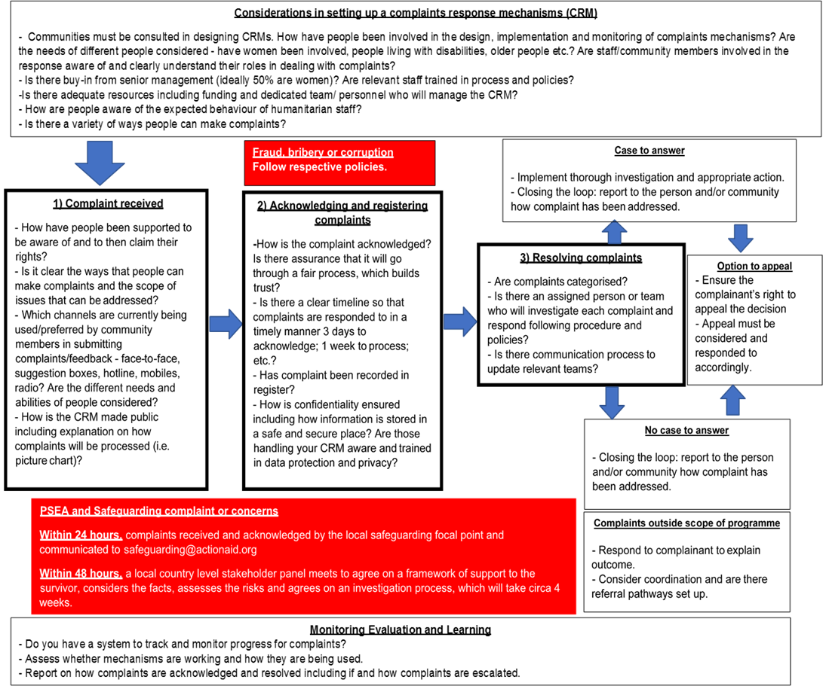

Setting-up a complaints and response mechanism (CRM)

Considerations for Covid-19
  - Is it feasible to establish joint CRMs with other agencies/organisations – particularly partnering with government for COVID-19 complaints/feedback?
  - Is social distancing currently in place? Are there restrictions on movement and access (e.g., lockdowns or community quarantines) and how can this affect the CRM?
  - What are social norms within your target communities which might affect the design of the CRM? Have you identified any barriers that may prevent people from providing complaints/feedback (e.g., lack of access, physical distance, cultural norms, etc)?
  - Are there rumours/norms specifically about COVID-19 that may hinder people from providing complaints/feedback (for example, misinformation about how CRM is transmitted, or risk of social stigma for people who may have contracted COVID-19)?

Best practice
  - In consulting communities, do no harm and follow social distancing. Avoid certain face-to-face activities such as community meetings or focus group discussions with more than 5 people.
  - If conducting needs assessment, include questions on accountability/CRM.
  - Ideally there should be more than one CRM channel. Focus on a small number of channels first (at least 2), and then adapt, improve and add if necessary.
  - Consider accessibility – particularly for people without access to phones or internet, women, children, and people with disabilities. For example, there are no-phone/low-tech ways for reporting SHEA/safeguarding concerns including during social distancing (e.g. using code words, wearing a particular piece of cloth, etc).
  - Avoid increasing social stigma related to COVID-19 for people who may want to access the CRM
– for example, in posters/IEC materials advertising the CRM, refer to “people who have COVID- 19” or “people who are being treated for COVID-19” instead of “cases” or “victims”.
  - Inform the communities of the availability of CRMs, and what they should expect when they submit a complaint.
  - Counter any misinformation about COVID-19.

Receiving, acknowledging and registering complaints

Considerations for Covid-19
  - Will policies on complaints response timelines be fulfilled if there is social distancing in place?
  - In collecting face-to-face feedback will your personnel have adequate protective gear and follow social distancing measures?
  - In categorising complaints/feedback, will it be useful to have a separate category for Covid-19 related complaints/feedback that could be quickly referred to relevant actors?
  - Crisis comes with a surge of complaints/feedback – do you have enough staff capacity to temporarily cover the surge in complaints/feedback?
  - If staff are working from home, do they have the adequate tools and technologies to receive, acknowledge and register complaints?

Best practice
  - IMPORTANT: For Sexual Harassment Exploitation and Abuse/Safeguarding related complaints, please follow the appropriate process in box below. For fraud, bribery, corruption and terrorism related complaints, please follow relevant policies.
  - Ideally suggestion boxes are opened once every 14 days and communities should know this
  - Ideally there is a dedicated staff/team tasked with processing complaints
  - Categorise the complaints and feedback received. For example, “Category 1: positive feedback, Category 2: request for assistance, Category 3: minor complaints” etc.
  - Have a policy on timeframe for acknowledging, processing, responding and closing complaints– ideally: 3 days to acknowledge; 1 week to process; 4 weeks to resolve.
  - Ensure gender-balance among staff acknowledging and registering complaints
  - Record CRM data in a secure and safe manner (e.g., using password-protected spreadsheets; keeping logbooks in locked containers). Do not use staff’s personal phone/computer when working from home (esp. for data privacy reasons) – this must be provided by ActionAid.

Resolving complaints

Considerations for Covid-19
  - Will you be able to refer Covid-19 related complaints/feedback outside ActionAid’s scope to existing Covid-19 referral systems in-country (for example, government hotlines). In reporting back to the community, will you be able to anonymise Covid-19 related complaints/feedback?
  - If Covid-19 related measures (such as lockdowns) prevent the resolution for now, will you be able to communicate transparently and keep track for later?

Best practice
  - Involve the relevant individuals/wider community as much as possible in determining the course of action to take to resolve the complaint (for example, if a design is not working, consult communities on how it can be fixed).
  - Take all complaints seriously. Demonstrate that all reasonable effort was made in addressing the issue.
  - Be transparent in reporting back to the community: feedback was not resolved, say so

Other resources

Setting up a complaints response mechanism
- Free online training on CEA (including on CRMs) - including a 3-hour online training package
- Menu of needs assessment questions on accountability/CRM (IASC)
- Sample guidance on CFM roles and responsibilities (CARE)
- Feedback starter kit – including sample budget (IFRC)
- Hotline in a box toolkit (IFRC)
- Guidance on how to use social media as part of your CFM (IFRC)
- Guidance on avoiding social stigma during COVID-19 (IFRC)
- Guide on using WhatsApp for mass messages and surveys
- “Not just hotlines and mobile phone”: GBV service provision during COVID-19 (UNICEF)
- Study on what prevents people from reporting misconduct (in Myanmar and Iraq) (Oxfam)
- Example of what to tell communities in informing them about the CFM and the organisation (CARE) - please adapt for ActionAid as necessary
Acknowledging, receiving and registering complaints
- Example of complaint/feedback categorisation (p. 24) and timelines for response (p. 30) (CARE)
- Guidance on safe and remote community engagement during COVID-19 (IFRC)- in particular the last 10 pages on practical ways to do this e.g., closed WhatsApp groups, etc
- Study on how to develop a centralised mobile-based complaints/feedback mechanism (Oxfam)
Resolving complaints
- Tool for mapping stakeholders for establishing referral systems (CARE)
- Sample CFM monthly reporting template (CARE)

Considerations for Sexual Harassment Exploitation and Abuse (SHEA) and Safeguarding:

The Global SHEA and Safeguarding Team has developed a new guidance note for all ActionAid staff on SHEA and Safeguarding in ActionAid’s COVID-19 Response – SHEA, PSEA and Child Safeguarding. Please see the link for a more comprehensive guidance.

Key message

All complaints mechanisms visibility material must emphasise the following commitments:
☒ Sexual activity with children is prohibited and constitutes sexual abuse.
☒ Sexual relationships with community members receiving aid is prohibited.
☒ Buying of sex is considered exploitation and is prohibited.
☒ Sex in exchange for aid constitutes abuse.

Key points

    - As part of embedding SHEA and Safeguarding into all COVID 19, programme design and activities, complaints mechanisms must be established in order to ensure that rights holders including children, and community members, including adults at-risk are able to raise concerns about abuse and exploitation.

    - Staff should work in a participatory and safe way with rights holders and communities (e.g. local committees) to create, strengthen, and evaluate existing complaints mechanisms in line with best practice, and ensure that the mechanisms used are relevant to the local context, translated into local languages, and made publicly available (e.g. published on the website).

    - Staff must ensure that policies and procedures are shared with rights holders and community members in a way that does not put them at risk of contraction of COVID-19, including adults at-risk so they can provide feedback and be instrumental in developing our approach.

    - SHEA and Safeguarding Focal Points are responsible for reporting all concerns and complaints to the Global SHEA and Safeguarding Team to ensure oversight of the Global Team.

    - The SHEA and Safeguarding Focal Point must complete a SHEA and Safeguarding Incident Reporting Form and send this to safeguarding@actionaid.org within 24 hours (where possible) of a concern being raised. The Global SHEA and Safeguarding Team will support the ActionAid

country to respond to all concerns and complaints raised, and monitor actions taken.
- Where helpdesks are available, with focal points in place, spaces must adhere to regulations on social distancing and are equipped with hygiene and sanitation facilities.

Guidance for implementation of complaints mechanisms

Child safeguarding

- Children are participating in complaints mechanisms design in a safe and effective way, that does not put them at risk of contracting COVID-19.
- Complaints mechanisms are accessible and friendly to children from marginalised groups, including LGBTTQI, children with special needs, children living with disabilities.
- Complaints mechanisms for SHEA and Safeguarding include a variety of mechanisms.
- Frontline staff are trained to receive complaints from children.
- Hotline staff are trained to receive complaints from children.
- Child friendly spaces include mechanisms for children to complain, for example toys are safe.
- Complaints mechanisms must indicate that survivors of child abuse and exploitation will be respected.
- Children will be listened to and treated with dignity.

Sexual abuse and exploitation

- Women friendly spaces are available in all COVID-19 response sites.
- Women friendly spaces that have designated areas for complaints are marked and adhering to regulations on social distancing.
- All women-friendly spaces with designated spaces for complaints have access to sanitation facilities.
- Each response site has a helpdesk or protection focal point who can take a complaint from survivors.
- All first responder staff are trained on survivor- centred approaches.
- Sanitation facilities are designed in a way that is sex and gender disaggregated where there is low risk of occurrence of sexual violence.
- Complaints mechanisms are owned by feminist-humanitarian networks.
- Feminist humanitarian networks are sufficiently trained to receive complaints and are adopting survivor-centred approaches.
- Complaints mechanisms are accessible and safe to adults with special needs, including
- persons with disabilities.
- Complaints mechanisms must be available for adults who are receiving aid but who cannot read and write.
- Complaints mechanisms indicate that survivors will be treated with respect and dignity.

Annex B Further Reading
- ActionAid International’s “Accountability in Emergencies: Resource book”, 2014
- ActionAid International, Child Safeguarding Policy, 2019
- ActionAid International, Global PSEA Policy, 2019
- ActionAid, COVID-19, Complaints Response Mechanism Guidance Note
- ActionAid Kenya, Women on the Forefront in Bringing Change, Newsletter, March 2020
- Hotline in a Box, “Getting Started with Hotline in a Box”, page 53, 2020, available from https://communityengagementhub.org/wp-content/uploads/sites/2/2020/04/200325_Full-toolkit.pdf
- Inter-Agency Standing Committee (IASC), Best Practice Guide Inter-Agency Community-Based Complaints Mechanisms, 2016
- Save the Children, “Safeguarding in Emergencies Toolkit”, 2019
- UNICEF, “Not Just Hotlines and Mobile Phones: GBV Service Provision During Covid-19”, 2020

