Community Based Safeguarding Visual Toolkit
Facilitation Guide
November 2022

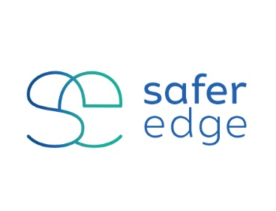
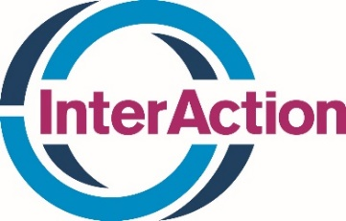

Acknowledgements
This facilitation guide was developed by SaferEdge in partnership with Food for the Hungry. This product was made possible in part through the support of InterAction.

The contents of this facilitation guide are to be used in coordination with the Community Based Safeguarding Visual Toolkit developed by Habitat for Humanity International, Oxfam International, and WaterAid.

Food for the Hungry (FH) wishes to thank Safer Edge for their work to write and design this facilitation guide and to InterAction for their generosity in helping to fund this project.

This guide is provided by InterAction for general distribution and use.

Table of Contents
Introduction 4
How to Use this Facilitation Guide 4
Lesson 1: Aid Workers Must Treat Everyone with Respect 9
Lesson 3: Aid Workers are Not Allowed to Ask for or Accept Bribes for Aid 16
Lesson 4: Aid Workers are Not Allowed to Have Sexual Relationships with Community Members 19
Lesson 5: Aid Workers are Not Allowed to Ask for or Accept Bribes for Employment 23
Lesson 6: Aid Workers Must Never Pay for Sex 27
Lesson 7: Aid Workers Must Never Have Relationships with Anyone Under 18 Years Old 30
Lesson 8: Aid Organizations Encourage Complaints - There Are Safe Ways to Complain 34
Lesson 9: Aid Workers Must Never Harass You 37
Lesson 10: Aid Workers Must Never Exchange Aid for Sex 41
Lesson 11: Aid Workers Must Never Exchange Sex for Employment 45

Introduction
This Facilitation Guide is a companion piece to the Community Based Safeguarding Visual Toolkit. Click here to view the available translations. This facilitation guide is for any staff to use and outlines how to carry out awareness raising activities with communities about Safeguarding.

How to Use this Facilitation Guide
As you prepare to engage with community members:
- First, access the Community Based Safeguarding Visual Toolkit. This will provide guidance on modifying colours, backgrounds, and making additional edits if needed.
- Then, use this Facilitation Guide for instructions on how to use the Community Based Safeguarding Visual Toolkit and the Facilitation Guide together to engage community members about Safeguarding.

Icon Key
You will see icons in the lesson plan. These icons mean:

Key Messages | Materials | Time | Tip! | Close the Session

Tips for how to use this guide:
- First, select a visual in the Community Based Safeguarding Visual Toolkit.
- Then, go to the Image and linked lesson in this guide.
- Read the guidance and amend for your community/context as appropriate.
- Discuss with your Safeguarding Focal Point or the Safeguarding Lead as needed.
- Lessons can be delivered either one lesson per week or one lesson per month, depending on your engagement with communities.
- Lesson topics can be facilitated one at a time in a short session, or by bringing two or more lessons together for a longer session.
- Each lesson is approximately fifteen (15) minutes in length, but can be extended if needed.

Core Safeguarding messages to share in every lesson
- “Assistance is Always Free”.
- “[YOUR ORGANIZATION] staff should always treat you with care and respect.”
- “If you have any concerns about the behaviour of a [YOUR ORGANIZATION] staff, you should report it to the Safeguarding Focal Point or [insert list of feedback channels available in that community].”

Planning a session
Materials you will need:
- Pens, pencils/markers (different colours)
- Flipchart paper to draw/write on
- Notecards to draw/write on
- Laminated cards – half are smiley faces and half are frowning faces
- Laminated cards – half are green and half are red
- Small items that can be used to play with or share (e.g. buttons in different colours, paperclips, seeds, or any culturally appropriate items in the area you are working in)

Questions to ask yourself before delivering a lesson:
- How can I be present and open in this discussion? What things do I need to put to one side, so I can fully concentrate on this lesson?
- How can I make sure that everyone is involved in the discussion? How can I encourage people to speak and make this a safe space?
- Am I confident that I know how to refer people to support if needed? Do I know how to report a Safeguarding concern internally?
- Am I aware of the context, including cultural norms, and the different power dynamics here?
- Am I aware of who is marginalized in this context? What can I do to make sure those individuals/groups are involved, and know their rights under the Safeguarding policy?

How to integrate a Safeguarding topic to the wider community interaction:
These Safeguarding lessons will be delivered as part of the wider work [YOUR ORGANIZATION] is carrying out with communities (e.g. training sessions, meetings, or wider sector activities). When you are adding a Safeguarding lesson, consider the below:
- If you are presenting a scenario for participants to discuss, connect the scenario to the lesson (e.g. after a lesson on WASH, a Safeguarding scenario could be about safeguarding risks at a washpoint/toilet).
- Link the broader activity AND Safeguarding to [YOUR ORGANIZATION] organisational values, so participants understand why you are discussing Safeguarding. Make sure it is clear to participants how it connects to the wider lesson they had.
- If the main lesson has been long or has covered a ‘difficult’ topic (e.g. discussing child abuse), then carry out an activity to energize participants before beginning with the Safeguarding lesson. For example, get everyone to sing a song together (that everyone in the community will know) or ask a participant to tell a story or a joke to help break some tension and re-set the group so they are ready to discuss something new.

Closing a session
- Share key messages about Safeguarding at [YOUR ORGANIZATION].
- In communities where this is relevant/appropriate, you could give participants a printed reminder to take away (e.g. a business card sized paper that outlines what behaviour to expect from [YOUR ORGANIZATION] staff, and how to raise concern). Alternatively, a visual poster could be shared. [Add here a link to your organization’s location for templates, resources, tools, etc.] Remember to risk assess first – is it safe to share this in this context? Could this lead to any unintended harm?
- Remind people that they can speak to you separately and confidentially after the lesson if they want to.

Adaptation and contextualization
It is essential that lessons are adapted depending on the context. If we share content that is not relevant to a specific context in which we work, or we deliver a lesson that is offensive or excludes certain members of the community and Safeguarding harms will persist.
When preparing to deliver a Safeguarding lesson, consider the below and discuss with colleagues - including a Safeguarding Focal Point - for guidance on how to make the lesson contextualised and inclusive.

Time and venue for the lesson
When preparing a Safeguarding session, it is important to think about:
- What time you are holding this session (e.g. make sure the session is not carried out late in the day as this may lead to unintended risks for participants, and make it difficult for some community members to join).
- Where you are holding the session (e.g. is there space for people to sit comfortably together and work in separate groups? Are there specific needs for some participants (e.g. space for children to play/rest))? Will all ethnic groups feel comfortable in the space selected (e.g. is the meeting place at a particular leader’s house, at a particular religious institution?) Make sure the space where you are having the lesson is accessible for all (e.g. for people with disabilities).
- Who can join the session (e.g. make sure that everyone can join, and that men and women are at ease and able to fully participate)

Tip! Try to select a meeting place that is accepted by and welcoming to all community members of all religious/ethnic/family/clan/political affiliation and backgrounds.

Tip! Try to hold the session in a place where you have access to confidential space (e.g. a separate room in case anyone wants to speak to you about a confidential Safeguarding matter afterwards).

Disability and Inclusion
We must make these Safeguarding lessons as inclusive as possible, so that everyone - including people with disabilities – can safely engage.
We must:
- Make sure the space(s) we are meeting in are accessible.
- Think about different disabilities and barriers to engagement, and do what we can to make the lesson accessible to all (e.g instructions in braille, sign language interpreters, information presented in a visual way, a poster not just written or shared verbally).
- Remember to assist those who are illiterate or less comfortable writing, and highlight everyone’s contribution.

Words matter
It can be challenging to talk about sexual exploitation, abuse, harassment, and other harms. We must make sure our language and body language is sensitive and culturally appropriate.
Questions to ask ourselves before running a session:
- What words are used in this community to talk about sex and sexual violence? Are there euphemisms or alternative phrases that are used?
- Is the term ‘Safeguarding’ clear and easily translated? If not, think about whether to use another term or take time to unpack what the word Safeguarding means for [YOUR ORGANIZATION].
- How can we talk about difficult topics in a way that is sensitive, but is still clear? We don’t want anything ‘lost in translation’.
- Are there ‘gatekeepers’ (i.e. influential individuals, leaders, etc.) in the community that we need to engage with first, so they can help the Safeguarding discussions go forward smoothly?

Cultural Sensitivity
It is important that we are culturally sensitive and that we do not carry out activities that are offensive or exclude anyone.
- Change examples given in the Facilitation Guide if they are not culturally relevant or if there are examples that are more appropriate for the context.
- Adapt lessons if the activities suggested or tools used are not appropriate - e.g. if the colour red has negative connotations, use another more neutral colour.
- Make sure the examples or activities you are carrying out are appropriate for ALL, not only one group or one majority (e.g. one ethnic group).

If you have any questions, contact your Safeguarding Focal Point or the Safeguarding Lead.

Lesson 1: Aid Workers Must Treat Everyone with Respect
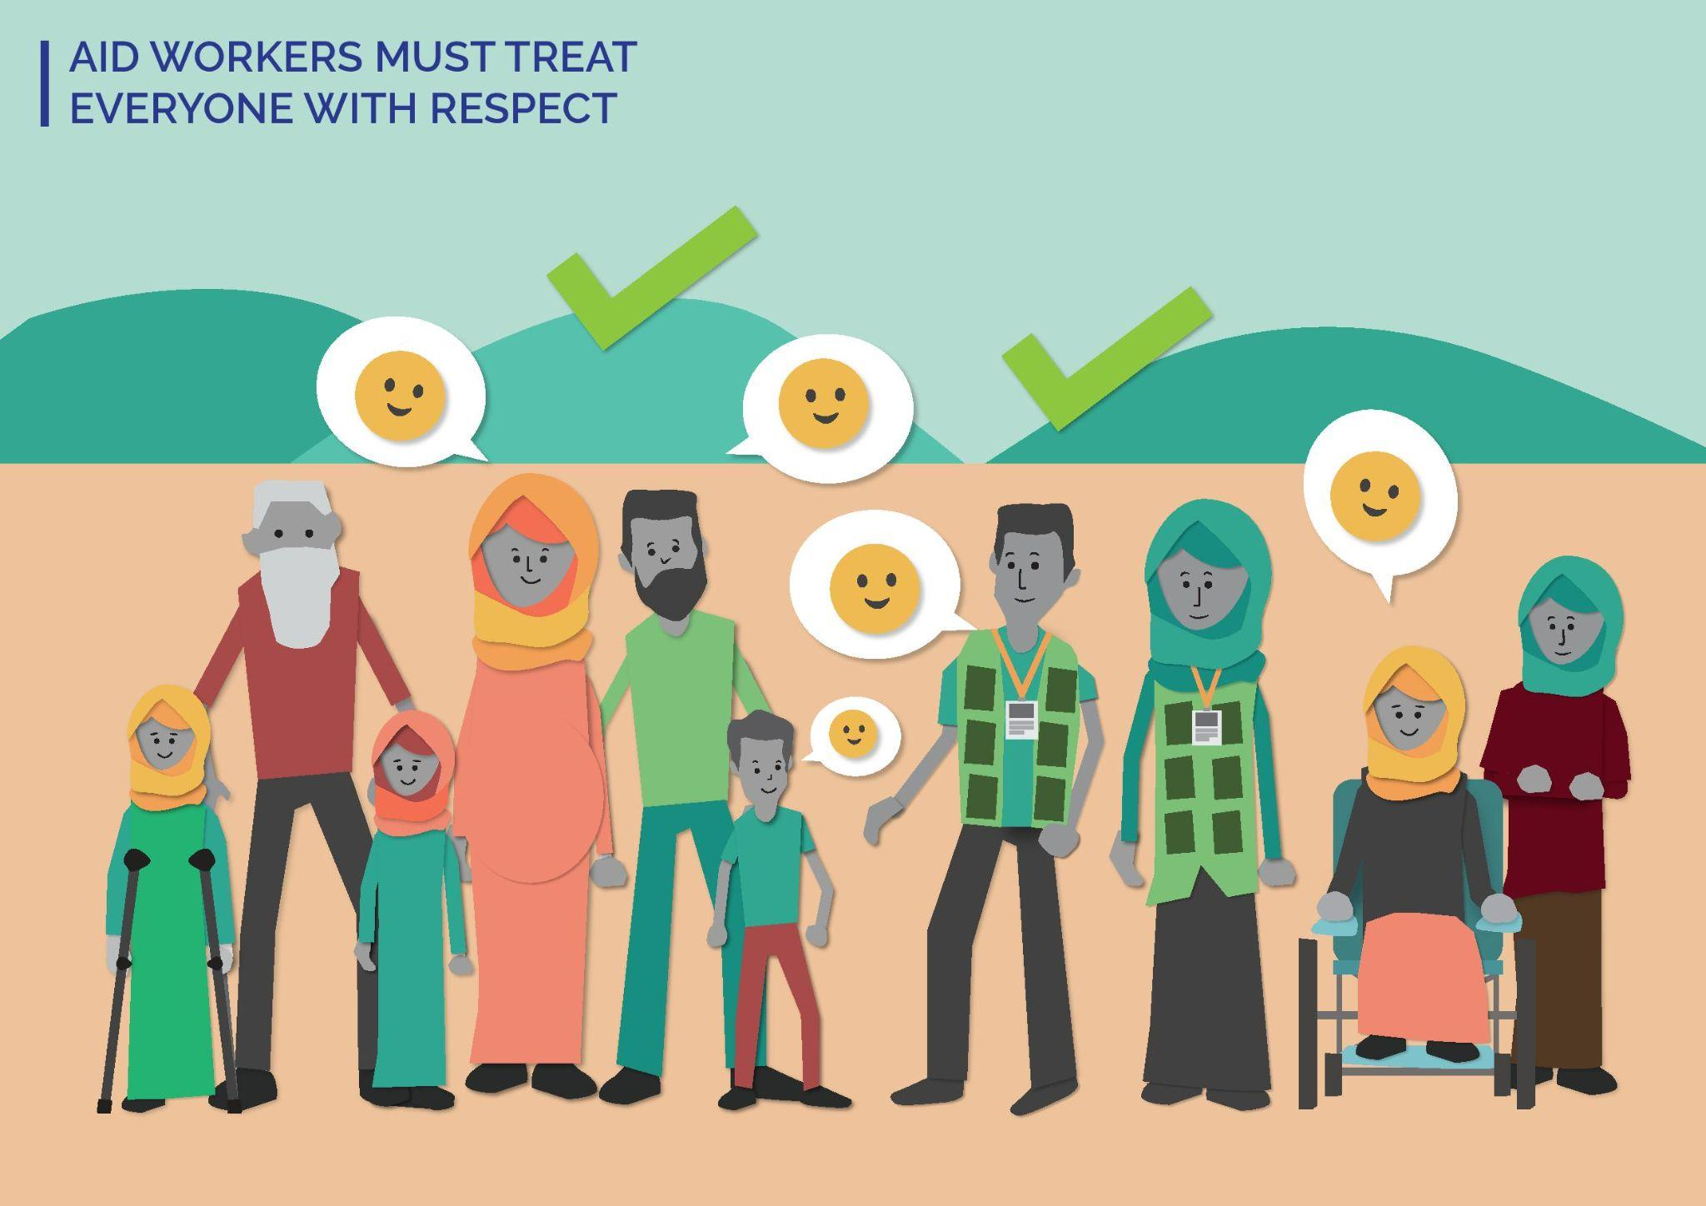
KEY MESSAGES TO SHARE IN THIS LESSON:
- Everyone deserves to be treated with respect.
- [YOUR ORGANIZATION] staff must treat everyone with respect and care at all times.
MATERIALS YOU WILL NEED FOR THIS LESSON:
- Pens, pencils/markers (different colours)
- Flipchart paper to draw/write on
- Laminated cards – half are smiley faces and half are frowning faces
- Laminated cards – half are green and half are red

Step 1
2 minutes
Introduce yourself as the facilitator and why you are facilitating this lesson:
- Let everyone know we will be talking about sensitive topics. Tell them that as facilitator, you will try to manage this conversation sensitively and safely, but if they find anything upsetting, they can take a break (e.g. step outside/get some water) and can speak to you afterwards if they want to.
- Remind everyone to treat each other with respect and care during the lesson. If there is particular language used about support or care in the community you are working on – reference this here.
Introduce Safeguarding at [YOUR ORGANIZATION]:
- Safeguarding is [YOUR ORGANIZATION] commitment to protecting program participants and community members from any form of harm caused by [YOUR ORGANIZATION].
- Safeguarding applies to all program participants and community members: children, women and men, people with disabilities. It applies to EVERYONE!

Step 2
10 minutes
Introduce the lesson for today – Aid Workers Must treat Everyone with Respect

Activity option 1:
Hand round cards with a smiley face and a frowning face on them. Every participant gets one of each card.
Read out six statements one by one. For each statement, ask participants if they would feel “respected” or “not respected” by putting up the smiley face card for “respected” and the frowning face card for “not respected”. If the face image is not culturally relevant/appropriate, you could use a green card for “respected” and a red card for “not respected” instead. If red has negative connotations, use a neutral colour or image instead.

Six statements:
- An [YOUR ORGANIZATION] staff asks me about my family and wishes them well. [Respected]
- An [YOUR ORGANIZATION] staff asks a parent/caregiver for consent before taking a photo of a child. [Respected]
- I see an [YOUR ORGANIZATION] staff shouting at a child and/or anyone in the community. [Not Respected]
- An [YOUR ORGANIZATION] staff is friendly to me, but I see them be rude to a woman in the community who has a disability. [Not Respected]
- I see an [YOUR ORGANIZATION] staff laugh at someone because of how they are dressed. [Not Respected]
- Two [YOUR ORGANIZATION] staff lead a lesson on [insert topic from main lesson (e.g. about WASH)]. They include program participants and community members who do not usually speak in lessons (e.g. people who are shy, people with learning disabilities). [Respected]
At the end, talk about [YOUR ORGANIZATION] approach and the importance of [YOUR ORGANIZATION] staff treating everyone with respect. You could ask prompt questions like:
- What does respect mean to you?
- How do you feel when you are being treated with respect?
- How do you feel when you are not treated with respect?

Activity option 2:
Draw a big picture of a house or meeting space [this should look like the buildings in the community you are in]. Ask participants what makes them feel safe?
Communities where writing is common - Hand out different coloured pens/markers and ask participants to add words to the picture to show what makes them feel safe and respected. Remember to assist those who are illiterate or less comfortable writing, and highlight everyone’s contribution.
Communities where writing is not common – Hand out different coloured pens/ markers and ask participants to add pictures to the drawing to show what makes them feel safe and respected.
At the end, ask everyone to look at the drawing together and discuss what they see.
Emphasise that [YOUR ORGANIZATION] staff must always treat everyone with respect. Explain that this is a core part of [YOUR ORGANIZATION] culture and values. If people have concerns about the behaviour of FH team members, they should report it.

Step 3
3 minutes
Remind everyone that:
- Assistance is Always Free.
- [YOUR ORGANIZATION] staff should always treat you with care and respect.
- If you have any concerns about the behaviour of a [YOUR ORGANIZATION] staff, you should report it to the Safeguarding Focal Point or [insert list of feedback channels available in that community].

Close the session: If it has been a difficult discussion, take time to check everyone is ok (e.g. stay after the lesson in case anyone wants to speak) and/or do a post-training energizer, so people leave feeling positive.
Tip! This lesson could be combined with any other of the Safeguarding lessons. It is a good way to lead into other Safeguarding topics as it gives a baseline about how people should be treated with respect.

Lesson 2: Aid Organizations Encourage Everyone to Report Abuse
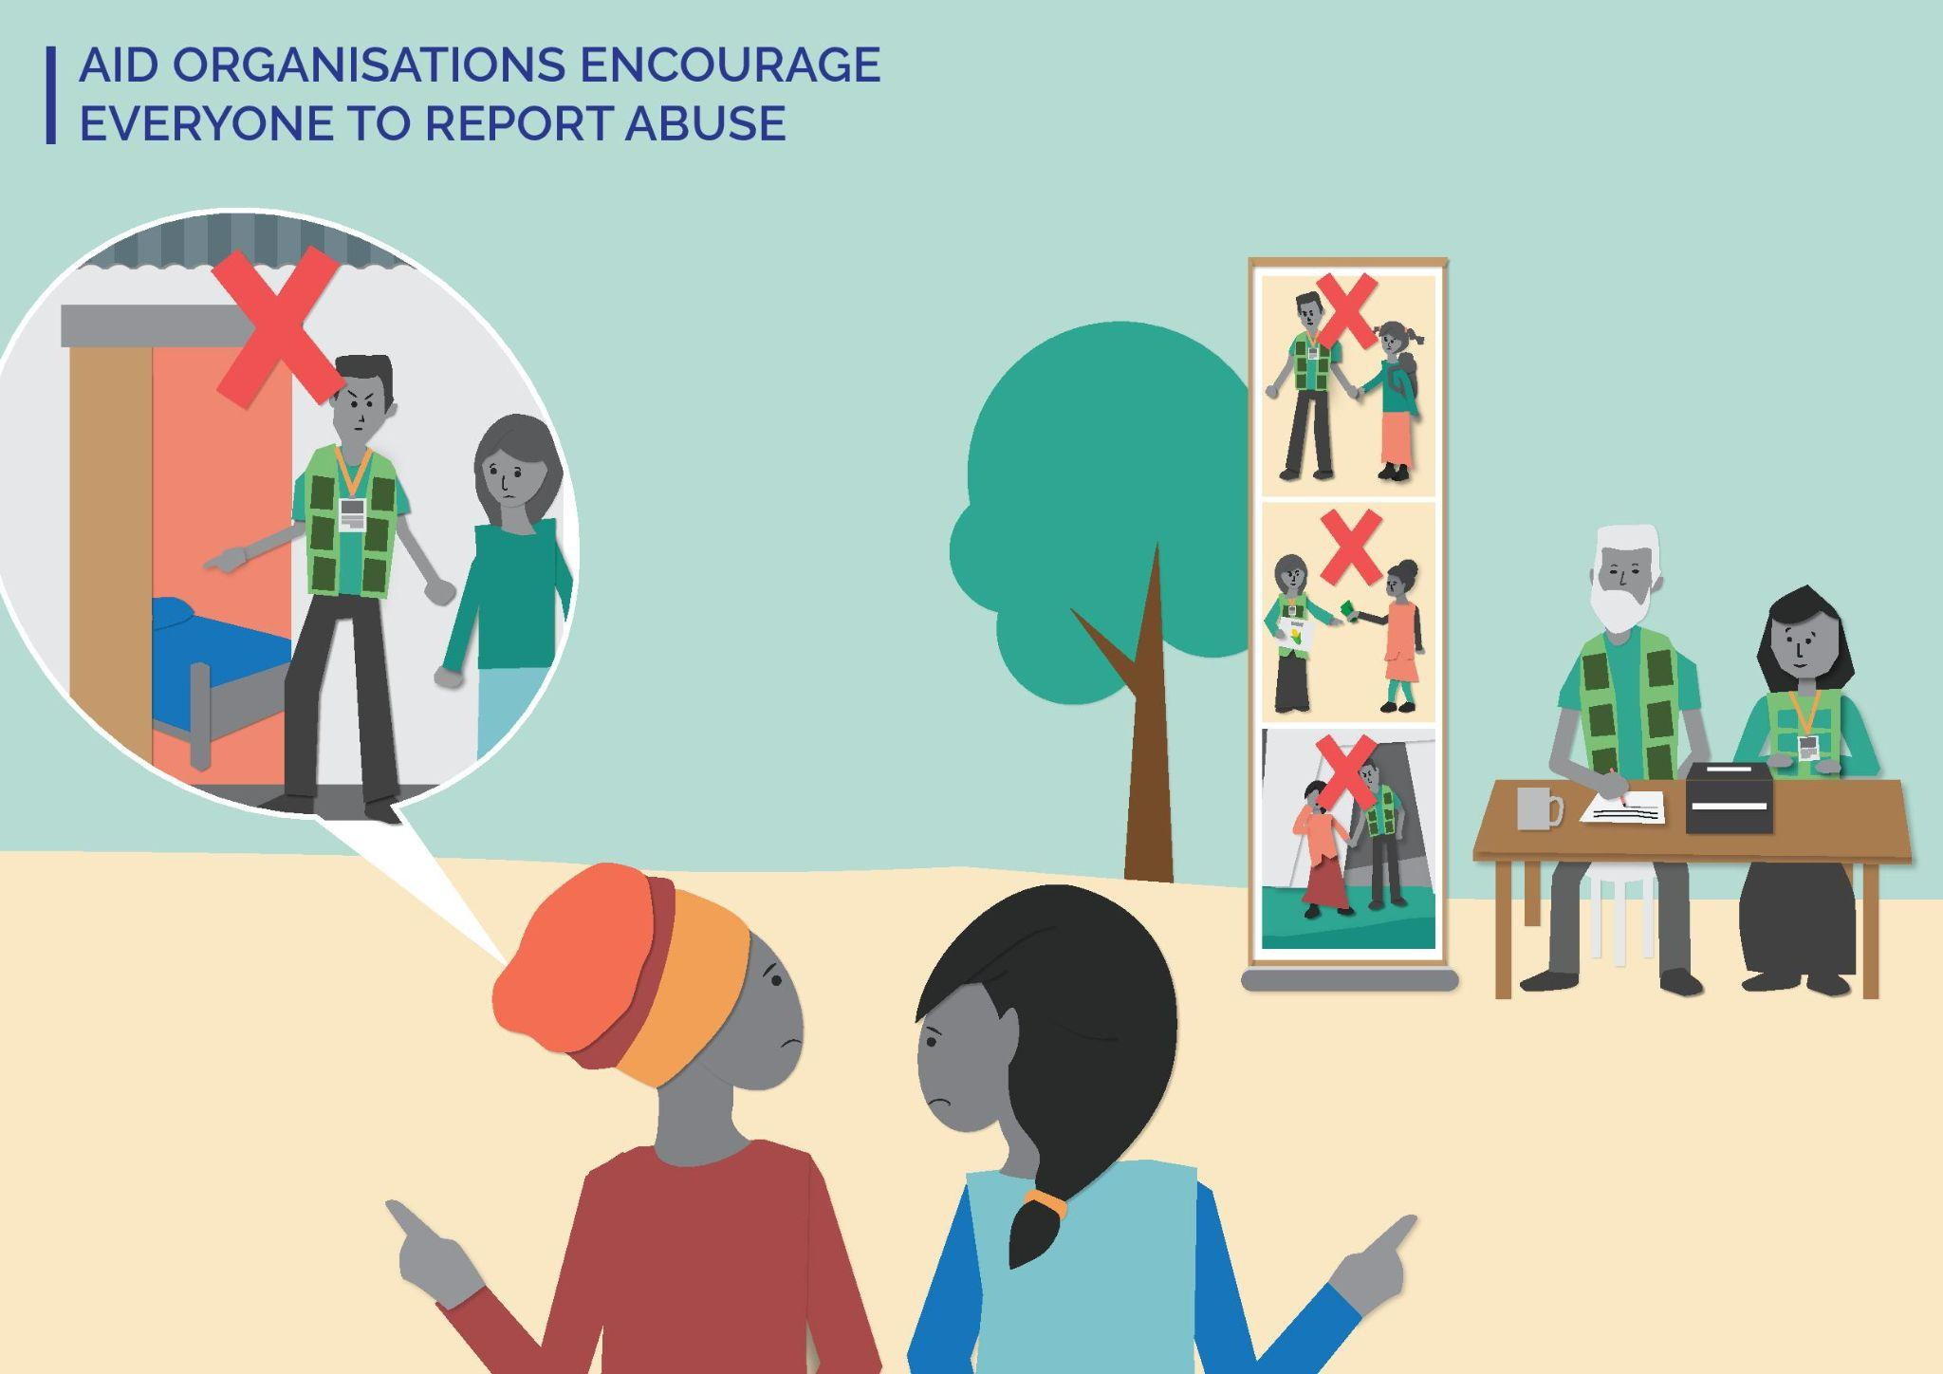
KEY MESSAGES TO SHARE IN THIS LESSON:
- [YOUR ORGANIZATION] encourages everyone to report abuse and has created safe ways to report.
- Complaints are how [YOUR ORGANIZATION] addresses problems and makes sure our approach is safe.
- People who report abuse will be protected. If you report abuse, this will not impact your engagement with [YOUR ORGANIZATION].
MATERIALS YOU WILL NEED FOR THIS SESSION:
- Pens, pencils/markers (different colours)

Step 1
2 minutes
Introduce yourself as the facilitator and why you are facilitating this lesson:
- Let everyone know we will be talking about sensitive topics. Tell them that as the facilitator, you will try to manage this conversation sensitively and safely, but if they find anything upsetting, they can take a break (e.g. step outside/get some water) and can speak to you afterwards if they want to.
- Remind everyone to treat each other with respect and care during the lesson. If there is particular language used about support or care in the community you are working on – reference this here.
Introduce Safeguarding at [YOUR ORGANIZATION]:
- Safeguarding is [YOUR ORGANIZATION] commitment to protecting program participants and community members from any form of harm caused by [YOUR ORGANIZATION].
- Safeguarding applies to all program participants and community members: children, women and men, people with disabilities. It applies to EVERYONE!

Step 2
10 minutes
Introduce the lesson for today – Aid organizations encourage everyone to report abuse

Activity option 1: Two [YOUR ORGANIZATION] staff perform two role plays about reporting abuse. One team member plays a community member coming to report abuse; the other an [YOUR ORGANZIATION] FH staff.
- Role Play 1: Show a ‘bad’ or negative way to report abuse. The [YOUR ORGANIZATION] staff receiving the complaint ignores the community member, tells them they are busy, asks them to share something in front of others, etc.
After the role play – open it up to discussion with the participants.
- What did they think of the [YOUR ORGANIZATION] staff’s behaviour?
- What could they have done differently?

- Role Play 2: Show a ‘good’ or positive way to report abuse. The [YOUR ORGANIZATION] staff receiving the complaint suggests that they go somewhere to speak privately, listens with empathy, and thanks the community member for reporting the abuse.
After the role play – open it up to discussion with the participants.
- What did they think of the [YOUR ORGANIZATION] staff’s behaviour?
- What was positive about this approach?

Outline [YOUR ORGANIZATION] community reporting approach and what [YOUR ORGANIZATION] has done to make reporting safe (e.g. established multiple safe reporting feedback channels, staff are trained to receive complaints, information kept confidential). Emphasize that [YOUR ORGANIZATION] will support people who report abuse and wants people to report, so [YOUR ORGANIZATION] can address issues and become safer.
Note to Facilitator: To learn more about [YOUR ORGANIZATION] community reporting approach, visit [LINK TO SOURCE].

Activity option 2:
In the space you are in, draw a line on the floor or have one person stand at the front and another at the back of the room or space to represent the beginning and end of a line. One end means “very comfortable” and the other means “not comfortable.” Read out statements and ask participants to show how comfortable they feel by placing themselves on the line.
Scenarios:
- Telling my friend she is a terrible person
- Hitting my friend because they have made a mistake
- Slapping a child because they talked too long
- Telling an [YOUR ORGANIZATION] staff that another [YOUR ORGANIZATION] staff touched me inappropriately
Outline [YOUR ORGANIZATION] reporting approach and what [YOUR ORGANIZATION] has done to make reporting safe (e.g. established multiple safe reporting feedback channels, [YOUR ORGANIZATION] staff trained to receive complaints, information kept confidential). [YOUR ORGANIZATION] will support people who report abuse and welcomes reports, so [YOUR ORGANIZATION] can address issues and become safer.
Note to Facilitator: To learn more about [YOUR ORGANIZATION] community reporting approach, visit [LINK TO SOURCE].

Then, ask them if they would change where they are standing because of this new information. If they do not change – tell them it is ok. Ask them:
- What would make it easier to raise complaints?
- What can [YOUR ORGANIZATION] do to make it easier?

Step 3
3 minutes
Remind everyone that:
- Assistance is Always Free.
- [YOUR ORGANIZATION] staff should always treat you with care and respect.
- Everyone is able to report abuse and [YOUR ORGANIZATION] has made sure there are safe ways to report. [YOUR ORGANIZATION] will do its best to protect people who report abuse.
- If you have any concerns about the behaviour of a [YOUR ORGANIZATION] staff, you should report it to the Safeguarding Focal Point or [insert list of feedback channels available in that community].
Close the session: If it has been a difficult discussion, take time to check everyone is ok (e.g. stay after the lesson in case anyone wants to speak) and/or do a post-training energizer, so people leave feeling positive.

Tip! This lesson could be combined with any other of the Safeguarding lessons. It is important that everyone knows how to report abuse or any complaint and feels safe to report. After a lesson on one of the other lessons, this lesson could be used as a reminder to encourage complaints.

Lesson 3: Aid Workers are Not Allowed to Ask for or Accept Bribes for Aid
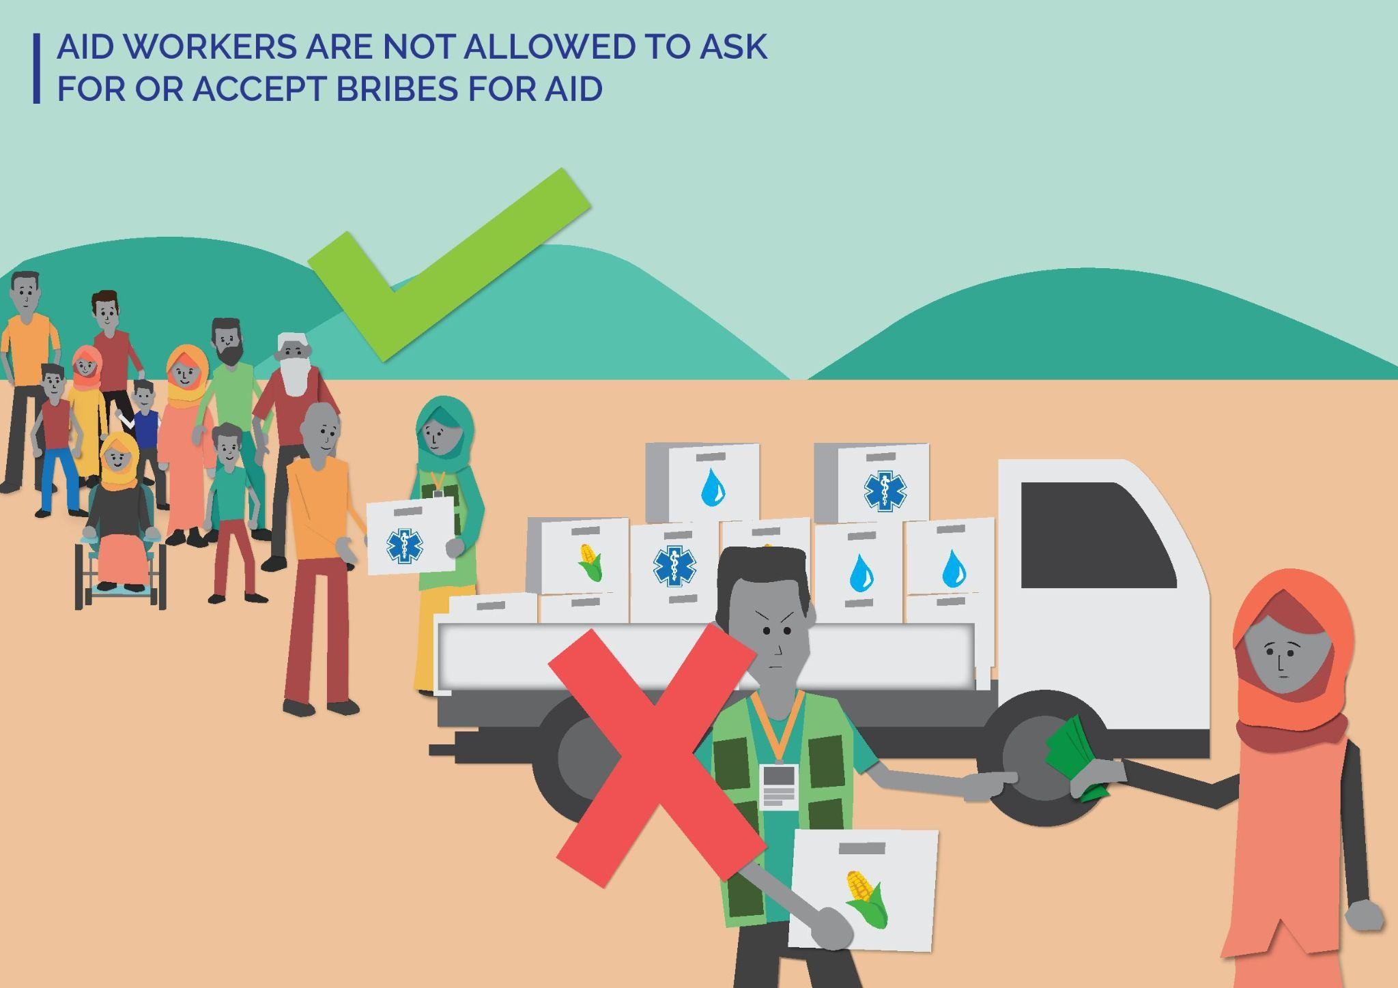
KEY MESSAGES TO SHARE IN THIS LESSON:
- Assistance is always free – you do not have to exchange anything to get aid/assistance from [YOUR ORGANIZATION].
- Do not offer to give [YOUR ORGANIZATION] staff anything in exchange for aid.
- [YOUR ORGANIZATION] staff must not ask you for money or anything else in exchange for aid.
MATERIALS YOU WILL NEED FOR THIS SESSION:
- Small items that can be used to play with or share (e.g. buttons in different colours, paperclips, seeds, or any culturally appropriate items in the area you are working in)

Step 1
2 minutes
Introduce yourself as the facilitator and why you are facilitating this lesson:
- Let everyone know we will be talking about sensitive topics. Tell them that as facilitator, you will try to manage this conversation sensitively and safely, but if they find anything upsetting, they can take a break (e.g. step outside/get some water) and can speak to you afterwards if they want to.
- Remind everyone to treat each other with respect and care during the lesson. If there is particular language used about support or care in the community you are working on – reference this here.
Introduce Safeguarding at [YOUR ORGANIZATION]:
- Safeguarding is [YOUR ORGANIZATION] commitment to protecting program participants and community members from any form of harm caused by [YOUR ORGANIZATION].
- Safeguarding applies to all program participants and community members: children, women and men, people with disabilities. It applies to EVERYONE!

Step 2
10 minutes
Introduce the lesson for today – Aid Workers are not allowed to ask for or accept bribes for aid

Activity option 1:
- Give everyone six coloured buttons (or another small item that comes in different colours). Give one participant six blue buttons, another participant six yellow buttons and so on (make sure the colours you use are appropriate for the context/community you are working in).
- Ask participants to move around and exchange items with others until everyone ends up with an equal amount and one of each kind of button.
- Bring the group together and then ask one or two participants if they will swap with you for something that is clearly unfair (e.g. that you will give them three buttons if they give you money or that you will take all the buttons from another participant and give them to this participant, if they give you two buttons.). This should be a fun and playful activity. Encourage them to refuse and challenge you!

After this, talk to the participants about [YOUR ORGANIZATION] commitment to equality and fairness (e.g. that it is not ok for some people to have more access/aid than others). Emphasize that [YOUR ORGANIZATION] staff cannot ask for or accept bribes for aid because this is unfair and can lead to harm.

Activity option 2:
Two [YOUR ORGANIZATION] staff perform two role plays about asking for a bribe. One [YOUR ORGANIZATION] staff plays a community member; the other plays an [YOUR ORGANIZATION] staff.
- Role Play 1: Show the [YOUR ORGANIZATION] staff asking for or accepting a bribe (e.g. the [YOUR ORGANIZATION] staff asks the community member for money in exchange for having more support from [YOUR ORGANIZATION] [insert topic from main lesson here (e.g. about WASH)] OR the community member offers a bribe to the [YOUR ORGANIZATION] staff and they say “yes.”
After the role play – open it up to discussion with the participants.
- What did they think of the [YOUR ORGANIZATION] behaviour?
- What could they have done differently?

- Role Play 2: Show an [YOUR ORGANIZATION] staff asking for a bribe and the community member refuses, and then reports this to [YOUR ORGANIZATION] OR show a community member offer a bribe and the [YOUR ORGANIZATION] staff refuse and explain why they cannot do this.
After the role play – open it up to discussion with the participants.
- What did they think of the [YOUR ORGANIZATION] staff behaviour here?
- What was positive about this approach?

Talk to the participants about [YOUR ORGANIZATION] commitment to equality and fairness (e.g. that it is not ok for some people to have more access/aid than others). [YOUR ORGANIZATION] staff cannot ask for or accept bribes for aid because this is wrong and can lead to harm.

Step 3
3 minutes
Remind everyone that:
- Assistance is Always Free.
- [YOUR ORGANIZATION] staff should always treat you with care and respect.
- Do not give something to an [YOUR ORGANIZATION] staff in exchange for aid – they cannot accept it.
- [YOUR ORGANIZATION] staff must never ask you to exchange anything for aid/assistance. If this happens, you should report it.
- If you have any concerns about the behaviour of a [YOUR ORGANIZATION] staff, you should report it to the Safeguarding Focal Point or [insert list of feedback channels available in that community].

Close the lesson: If it has been a difficult discussion, take time to check everyone is ok (e.g. stay after the lesson in case anyone wants to speak) and/or do a post-training energizer so people leave feeling positive.

Tip! This lesson could be combined with Lesson 5. You can bring the two topics together to highlight why this is wrong and show [YOUR ORGANIZATION] commitment to equality and equal access.

Lesson 4: Aid Workers are Not Allowed to Have Sexual Relationships with Community Members
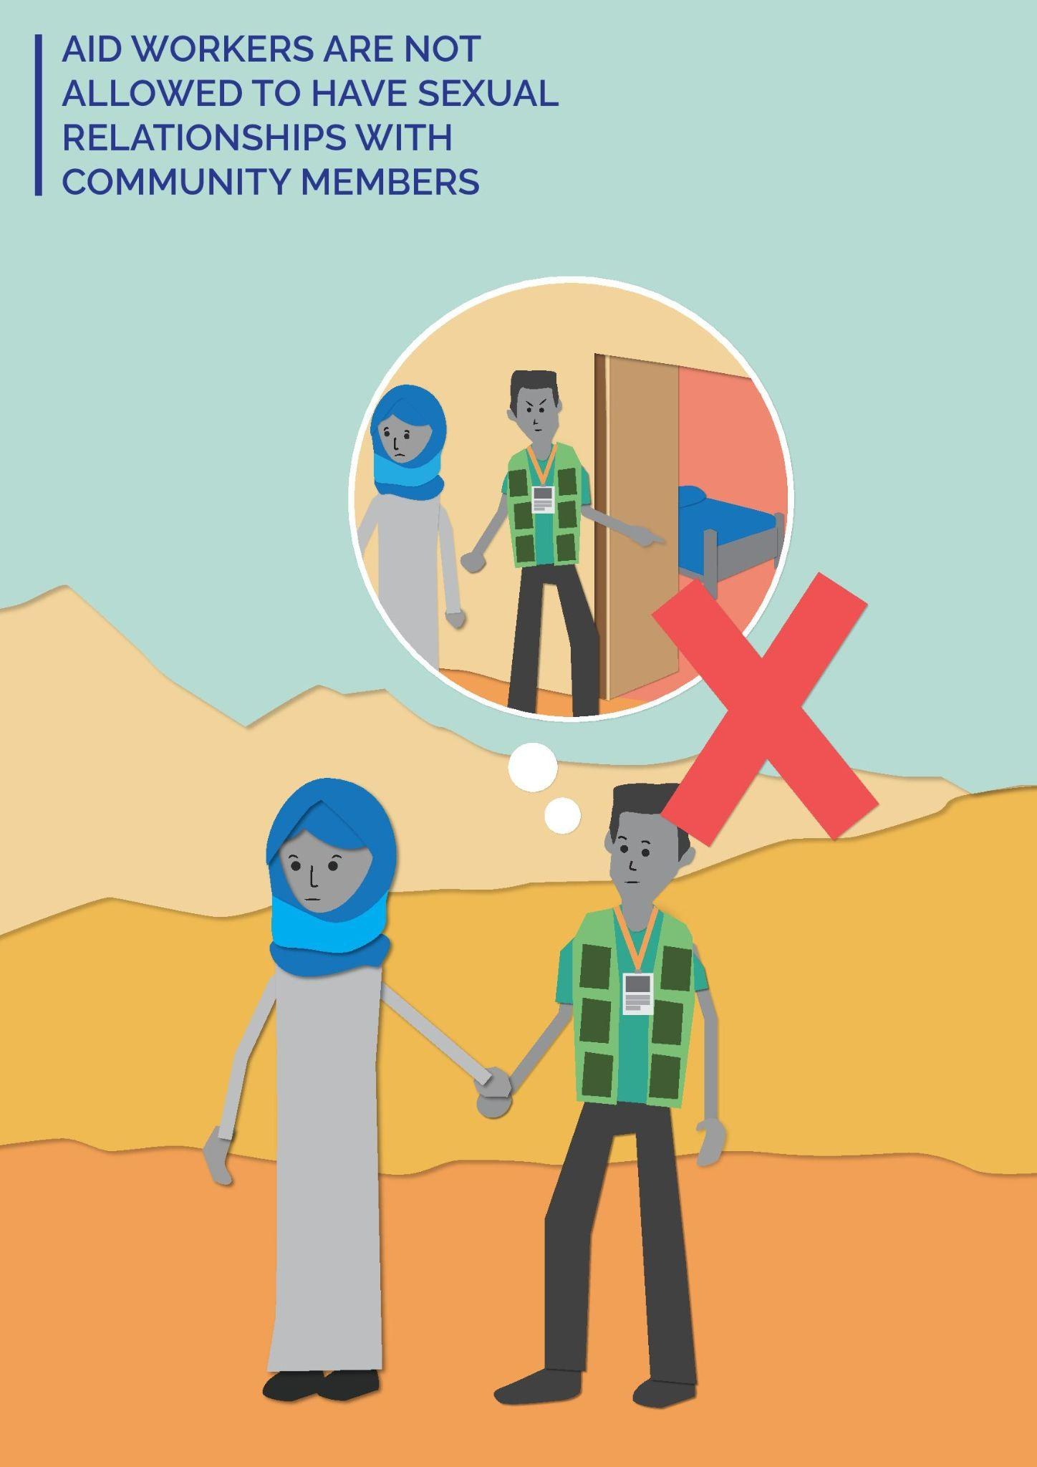

KEY MESSAGES TO SHARE IN THIS LESSON:
- Aid workers must treat everyone with respect.
- [YOUR ORGANIZATION] staff are not allowed to have sexual relationships with community members because:
  - [YOUR ORGANIZATION] staff have power in their role and they have to manage this responsibly.
  - [YOUR ORGANIZATION] staff have to treat everyone equally and cannot show favour to some people.
  - [YOUR ORGANIZATION] must not carry out any kind of behaviour that is or could be seen as being harmful or exploitative.
MATERIALS YOU WILL NEED FOR THIS SESSION:
- Pens, pencils/markers (different colours)
- Flipchart paper to draw/write on

Step 1
2 minutes
Introduce yourself as the facilitator and why you are facilitating this lesson:
- Let everyone know we will be talking about sensitive topics. Tell them that as facilitator, you will try to manage this conversation sensitively and safely, but if they find anything upsetting, they can take a break (e.g. step outside/get some water) and can speak to you afterwards if they want to.
- Remind everyone to treat each other with respect and care during the lesson. If there is particular language used about support or care in the community you are working on – reference this here.
Introduce Safeguarding at [YOUR ORGANIZATION]:
- Safeguarding is [YOUR ORGANIZATION] commitment to protecting program participants and community members from any form of harm caused by [YOUR ORGANIZATION].
- Safeguarding applies to all program participants and community members: children, women and men, people with disabilities. It applies to EVERYONE!

Step 2
10 minutes
Introduce the lesson for today – Aid Workers are not allowed to have sexual relationships with community members

Activity option 1:
Draw a circle on a big piece of paper. Tell participants that the circle represents the community they live in.
Communities where writing is common - Hand out different coloured pens/markers and ask participants to add words to the drawing to show who has power in the community and where power sits.
Communities where writing is not common – Hand out different coloured pens/ markers and ask participants to add pictures to the drawing to show who has power in the community and where power sits.

At the end, ask everyone to look at the drawing together and discuss what they see. If no one has put FH team members as having power, bring this up. Talk about the power [YOUR ORGANIZATION] staff have and explain that with this power comes responsibility.
Emphasize that [YOUR ORGANIZATION] staff must treat everyone with respect. [YOUR ORGANIZATION] staff cannot show favouritism or misuse the responsibility they have in any way. Relationships are prohibited because they can be abusive or can lead to abuse and we cannot do anything that stops us carrying out our work.

Activity option 2:
Talk about [YOUR ORGANIZATION] Safeguarding approach – that [YOUR ORGANIZATION] staff cannot have relationships with program participants or community members because of the power imbalance. [YOUR ORGANIZATION] is committed to treating everyone in an equal and fair way so relationships are prohibited.
- Put the participants into groups of four/five.
- Hand out a large sheet of paper per group. Ask participants to draw a poster for their community. The poster should explain that [YOUR ORGANIZATION] staff cannot have relationships with community members.
- At the end, get everyone to move around the room and ask each group to explain their poster. Talk to participants about the responsibility that [YOUR ORGANIZATION] have and that relationships with program participants and/or community members can be or seem to be exploitative.

Tip! After the training, you can use these posters in the community to highlight community rights and [YOUR ORGANIZATION] Safeguarding approach.

Step 3
3 minutes
Remind everyone that:
- Assistance is Always Free.
- [YOUR ORGANIZATION] staff should always treat you with care and respect.
- [YOUR ORGANIZATION] staff cannot have sexual relationships with community members because of the power imbalance. [YOUR ORGANIZATION] staff are there to support program participants and community members and uphold their rights. [YOUR ORGANIZATION] staff must not do anything that could be or could seem to be exploitative.
- If you have any concerns about the behaviour of a [YOUR ORGANIZATION] staff, you should report it to the Safeguarding Focal Point or [insert list of feedback channels available in that community].

Close the lesson: If it has been a difficult discussion, take time to check everyone is ok (e.g. stay after the lesson in case anyone wants to speak) and/or do a post-training energizer so people leave feeling positive.

Tip! This lesson could be combined with Lessons 7 or 9 to remind people that sexual relationships with children are also prohibited, and that [YOUR ORGANIZATION] staff cannot carry out any kind of harassing or inappropriate behaviour with program participants and community members.

Lesson 5: Aid Workers are Not Allowed to Ask for or Accept Bribes for Employment
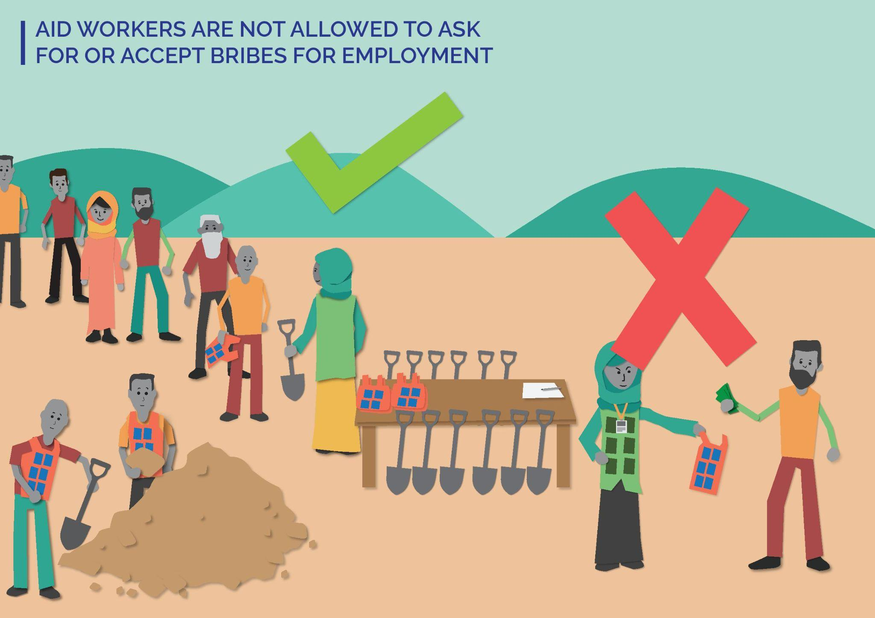
KEY MESSAGES TO SHARE IN THIS LESSON:
- All engagement with [YOUR ORGANIZATION] is free. You never have to exchange anything to get aid/assistance from [YOUR ORGANIZATION].
- Do not offer to give any [YOUR ORGANIZATION] staff anything in exchange for employment.
- [YOUR ORGANIZATION] staff must not ask you for money or anything else in exchange for employment.
MATERIALS YOU WILL NEED FOR THIS SESSION:
- Laminated cards – half are smiley faces and half are frowning faces
- Laminated cards – half are green and half are red

Step 1
2 minutes
Introduce yourself as the facilitator and why you are facilitating this lesson:
- Let everyone know we will be talking about sensitive topics. Tell them that as facilitator, you will try to manage this conversation sensitively and safely, but if they find anything upsetting, they can take a break (e.g. step outside/get some water) and can speak to you afterwards if they want to.
- Remind everyone to treat each other with respect and care during the lesson. If there is particular language used about support or care in the community you are working on – reference this here.
Introduce Safeguarding at [YOUR ORGANIZATION]:
- Safeguarding is [YOUR ORGANIZATION] commitment to protecting program participants and community members from any form of harm caused by [YOUR ORGANIZATION].
- Safeguarding applies to all program participants and community members: children, women and men, people with disabilities. It applies to EVERYONE!

Step 2
10 minutes
Introduce the lesson for today – Aid Workers are not allowed to ask for or accept bribes for employment

Activity option 1:
Two [YOUR ORGANIZATION] staff perform two role plays about asking for a bribe. One [YOUR ORGANIZATION] staff plays a community member; the other plays an [YOUR ORGANIZATION] staff.
- Role Play 1: Show the [YOUR ORGANIZATION] staff asking for or accepting a bribe (e.g. the [YOUR ORGANIZATION] staff asks the community member for money in exchange for getting them a job at [YOUR ORGANIZATION] OR the community member offers a bribe to the [YOUR ORGANIZATION] staff in exchange for a job. They say “yes.”
After the role play – open it up to discussion with the participants.
- What did they think of the [YOUR ORGANIZATION] staff’s behaviour?
- What could they have done differently?

- Role Play 2: Show the [YOUR ORGANIZATION] staff asking for a bribe in exchange for a job. The community member refuses and reports this to [YOUR ORGANIZATION] OR show the community member offering a bribe for a job and the [YOUR ORGANIZATION] staff refuses. Explains why they cannot do this.
After the role play – open it up to discussion with the participants.
- What did they think of the [YOUR ORGANIZATION] staff’s behaviour here?
- What was positive about this approach?

Talk to the participants about [YOUR ORGANIZATION] commitment to equality and fairness (e.g. that it is not ok for some people to get a job because they have more money/materials). [YOUR ORGANIZATION] has a fair and equitable approach to employment. It is not based on who you know or what you can pay. Emphasize that [YOUR ORGANIZATION] staff cannot ask for or accept bribes for employment because this is unfair and can lead to harm.

Activity option 2:
Hand out round cards with a smiley face and a frowning face on them. Every participant gets one of each card.
Read out four scenarios one by one. For each statement, ask participants if they think this is “ok” or “not ok” by putting up the smiley face card for “ok” and the frowning face card for “not ok”. If the face image is not culturally relevant/appropriate, use a green card for “ok” and a red card for “not ok” instead. If red has negative connotations, use a neutral colour or image instead.
Four scenarios:
- Your child has worked hard at school and they have trained to become an accountant/teacher/nurse [change as relevant for community/context or depending on the topic of the main lesson]. You find out that an [YOUR ORGANIZATION] staff gave a job [insert related job] to someone who gave them money even though your child is better qualified for the job. [Not ok]
- Your friend applies for a job with [YOUR ORGANIZATION] as an [change as relevant for community/context and amend depending on the topic of the main lesson]. They really want the job and need money to help their family. They offer the [YOUR ORGANIZATION] staff some money in exchange for the job. [Not ok]
- Your friend applies for a job at [YOUR ORGANIZATION] as an [change as relevant for community/context and amend depending on the topic of the main lesson]. They offer a bribe, but the [YOUR ORGANIZATION] staff refuses and explains that this is not allowed when applying for jobs at [YOUR ORGANIZATION]. [Ok]
- [YOUR ORGANIZATION] is advertising two new jobs. They advertise this in [insert the way in which information is shared with the whole community, as relevant for this community/context]. Remind everyone that anyone can apply and you don’t have to offer a bribe to get the job. [Ok]
Talk to the participants about [YOUR ORGANIZATION] commitment to equality and fairness (e.g. that it is not ok for some people to get a job because they have more money/materials).
[YOUR ORGANIZATION] has a fair and equitable approach to employment. It is not based on who you know or what you can pay. [YOUR ORGANIZATION] staff cannot ask for or accept bribes for employment because this is unfair and can lead to harm.

Step 3
3 minutes
Remind everyone that:
- Assistance is Always Free.
- [YOUR ORGANIZATION] staff should always treat you with care and respect.
- Do not give something to an [YOUR ORGANIZATION] staff in exchange for employment. They cannot accept it.
- [YOUR ORGANIZATION] staff must never ask you to exchange anything for employment. If this happens, you should report it.
- If you have any concerns about the behaviour of a [YOUR ORGANIZATION] staff, you should report it to the Safeguarding Focal Point or [insert list of feedback channels available in that community].

Close the lesson: If it has been a difficult discussion, take time to check everyone is ok (e.g. stay after the lesson in case anyone wants to speak) and/or do a post-training energizer so people leave feeling positive.
Tip! This lesson could be combined with Lesson 3. You can bring the two topics together to highlight why this is wrong and show [YOUR ORGANIZATION] commitment to equality and equal access.

Lesson 6: Aid Workers Must Never Pay for Sex
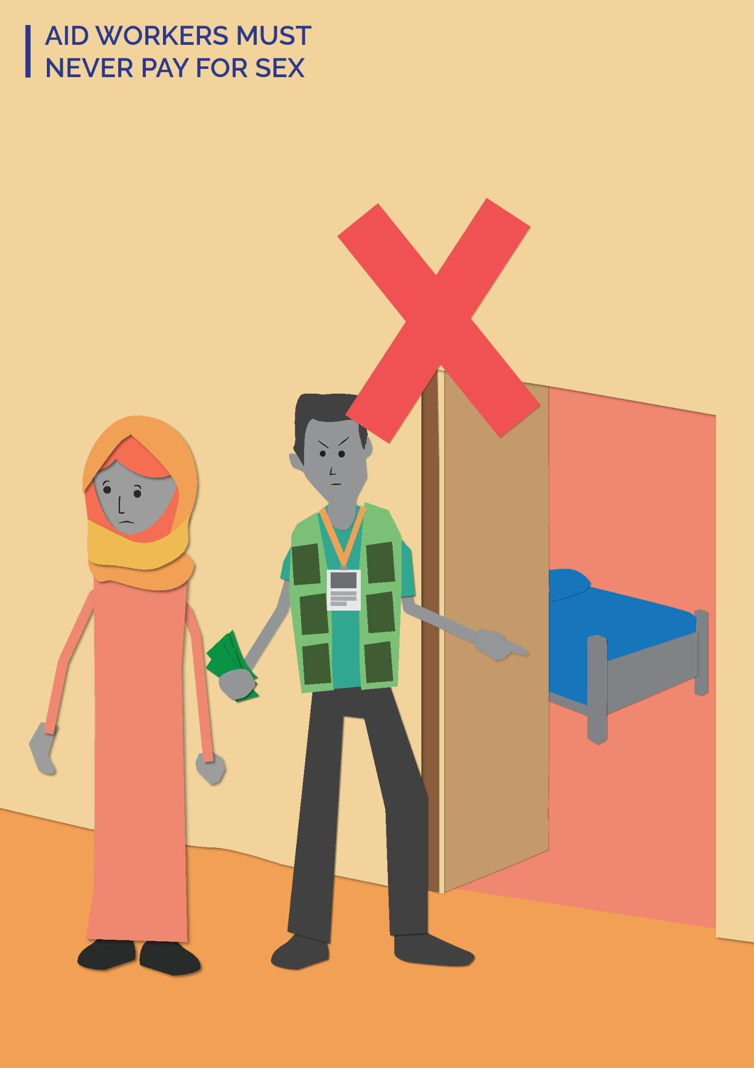
KEY MESSAGES TO SHARE IN THIS LESSON:
- [YOUR ORGANIZATION] staff must treat everyone with respect.
- [YOUR ORGANIZATION] staff cannot pay for sex.
- [YOUR ORGANIZATION] believes that payment for sex is exploitative and can cause harm.
MATERIALS YOU WILL NEED FOR THIS SESSION:
- Pens, pencils/markers (different colours)
- Flipchart paper to draw/write on
- Notecards to draw/write on

Step 1
2 minutes
Introduce yourself as the facilitator and why you are facilitating this lesson:
- Let everyone know we will be talking about sensitive topics. Tell them that as facilitator, you will try to manage this conversation sensitively and safely, but if they find anything upsetting, they can take a break (e.g. step outside/get some water) and can speak to you afterwards if they want to.
- Remind everyone to treat each other with respect and care during the lesson. If there is particular language used about support or care in the community you are working on – reference this here.
Introduce Safeguarding at [YOUR ORGANIZATION]:
- Safeguarding is [YOUR ORGANIZATION] commitment to protecting program participants and community members from any form of harm caused by [YOUR ORGANIZATION].
- Safeguarding applies to all program participants and community members: children, women and men, people with disabilities. It applies to EVERYONE!

Step 2
10 minutes
Introduce the lesson for today – Aid workers must never pay for sex.

Activity option 1:
In the space you are in, put pens/ markers on the floor to represent three areas or ask three people to represent three areas. Area 1= this is ok. Area 2 = this is not ok but I would not report to [YOUR ORGANIZATION]. Area 3 = this is not ok and I would report to [YOUR ORGANIZATION].
Read out statements and ask participants to stand in the area they agree with (e.g. if they think a scenario is ok, they would move to stand in that area/by that person).
Scenarios:
- An [YOUR ORGANIZATION] staff is friendly and walks me home if it is late and I am alone. [Acceptable – but outline how this could be a problem]
- An [YOUR ORGANIZATION] staff tells me they like my clothes/shoes. [Acceptable – but outline how this could be a problem]
- I see an [YOUR ORGANIZATION] staff paying for sex from a woman in the community. [Unacceptable and should be reported]
- An [YOUR ORGANIZATION] staff tells me I can receive aid only if I have sex with them. [Unacceptable and should be reported]
Outline [YOUR ORGANIZATION] Safeguarding approach – that [YOUR ORGANIZATION] staff cannot pay for sex because this is a form of exploitation and can lead to harm. [YOUR ORGANIZATION] is committed to treating everyone in an equal and fair way and this behaviour is prohibited. Ask them if they would change where they are standing because of this new information.

Activity option 2:
Draw a big picture of a heart [or another culturally appropriate image that represents care/support]. Ask participants:
- What makes them feel respected?

Communities where writing is common - Hand out different coloured pens/markers and ask participants to add words to the heart to show how to behave in a respectful way and treat people with care.
Communities where writing is not common – Hand out different coloured pens/ markers and ask participants to add pictures to the drawing to show how to behave in a respectful way and treat people with care.

At the end, ask everyone to look at the drawing together and discuss what they see. Emphasize that [YOUR ORGANIZATION] staff must always treat everyone with respect. Explain that this is a core part of [YOUR ORGANIZATION] culture and values, and that as part of that, [YOUR ORGANIZATION] staff cannot pay for sex as this is exploitative and can lead to harm. Remind them that if they have complaints about the behaviour of [YOUR ORGANIZATION] staff, they should report it.

Step 3
3 minutes
Remind everyone that:
- Assistance is Always Free.
- [YOUR ORGANIZATION] staff should always treat you with care and respect.
- [YOUR ORGANIZATION] staff must not buy sex as this is exploitative and can lead to harm.
- If you have any concerns about the behaviour of a [YOUR ORGANIZATION] staff, you should report it to the Safeguarding Focal Point or [insert list of feedback channels available in that community].

Close the lesson: If it has been a difficult discussion, take time to check everyone is ok (e.g stay after the lesson in case anyone wants to speak) and/or do a post-training energizer so people leave feeling positive.

Tip! This lesson could be combined with Lessons 1 or 9 to emphasise that everyone must be treated with respect, and any inappropriate behaviour by [YOUR ORGANIZATION] staff will not be tolerated.

Lesson 7: Aid Workers Must Never Have Relationships with Anyone Under 18 Years Old
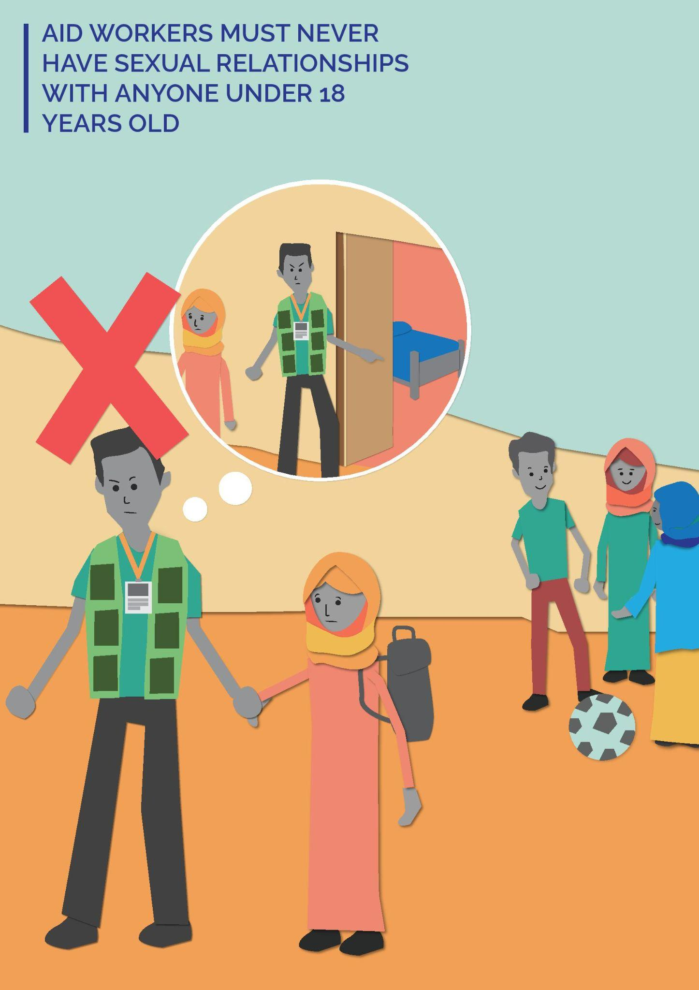
KEY MESSAGES TO SHARE IN THIS LESSON:
- [YOUR ORGANIZATION] defines a child as anyone under the age of 18. This is an international standard.
- All children must be treated with care and respect. [YOUR ORGANIZATION] staff must respect the human rights of children at all times.
- [YOUR ORGANIZATION] staff must not have sexual relationships with children - this is abuse.
MATERIALS YOU WILL NEED FOR THIS SESSION:
- Pens, pencils/markers (different colours)
- Flipchart paper to draw/write on
Step 1
2 minutes
Introduce yourself as the facilitator and why you are facilitating this lesson:
- Let everyone know we will be talking about sensitive topics. Tell them that as facilitator, you will try to manage this conversation sensitively and safely, but if they find anything upsetting, they can take a break (e.g. step outside/get some water) and can speak to you afterwards if they want to.
- Remind everyone to treat each other with respect and care during the lesson. If there is particular language used about support or care in the community you are working on – reference this here.
Introduce Safeguarding at [YOUR ORGANIZATION]:
- Safeguarding is [YOUR ORGANIZATION] commitment to protecting program participants and community members from any form of harm caused by [YOUR ORGANIZATION].
- Safeguarding applies to all program participants and community members: children, women and men, people with disabilities. It applies to EVERYONE!

Step 2
10 minutes
Introduce the lesson for today – Aid workers must not have relationships with anyone under 18 years old.

Activity Option 1:
In the space you are in, draw a line on the floor or get two people to represent the beginning and end of a line. One end means “This is ok” and the other means “This is not ok.” Read out statements and ask participants to show whether they “agree” or “disagree” by placing themselves on the line.
Scenarios:
- Before taking any photographs, [YOUR ORGANIZATION] staff must get informed consent from the parents/caregivers of children. [Ok]
- A 17 year old girl likes a [YOUR ORGANIZATION] staff and wants to start a relationship with them. The girl’s family agrees this is ok, so the [YOUR ORGANIZATION] staff starts a relationship with her. [Not ok]
- An [YOUR ORGANIZATION] staff gives extra help to a little boy who is struggling at school. Other children get jealous and start to bully the boy. [Not ok]
- [YOUR ORGANIZATION] staff do not work 1:1 with children; two adults work with children. [Ok]
- An [YOUR ORGANIZATION] staff invites a child to his or her house to clean for them. When the child is there, the child breaks something and the staff hits them. [Not ok]
Emphasize that children must be treated with care and respect. At [YOUR ORGANIZATION], a child is anyone under the age of 18 years old. Sexual relationships are prohibited because of the unequal power between adults and children. Children cannot consent and any sexual relationship is a form of abuse. Ask if they would change where they are standing because of this new information.
Activity option 2:
Draw an outline of a child on a big piece of paper. Ask participants:
- How should children be treated?
- How can we protect children?
- How can we help children uphold their rights?

Communities where writing is common - Hand out different coloured pens/markers and ask participants to add words to the drawing to show how we should treat children and how we can keep children safe.
Communities where writing is not common – Hand out different coloured pens/ markers and ask participants to add pictures to the drawing to show how we should treat children and how we can keep children safe.

At the end, ask everyone to look at the drawing together and discuss what they see. If no one has brought up not having sexual relationships with children, then raise this.
Emphasize that children must be treated with care and respect. At [YOUR ORGANIZATION], a child is anyone under the age of 18 years old. Sexual relationships are prohibited because of the unequal power between adults and children. Children cannot consent and any sexual relationship is a form of harm and abuse.

Step 3
3 minutes
Remind everyone that:
- Assistance is Always Free.
- [YOUR ORGANIZATION] staff should always treat you with care and respect.
- [YOUR ORGANIZATION] is committed to making sure children are safe and their rights are upheld.
- Sexual relationships between [YOUR ORGANIZATION] staff and any community member or program participant, including children, is strictly prohibited.
- People who raise complaints will be protected. If someone raises a complaint, it will not impact their engagement with [YOUR ORGANIZATION] and information will be kept confidential.
- If children or adults have any concerns about the behaviour of a [YOUR ORGANIZATION] staff, you should report it to the Safeguarding Focal Point or [insert list of feedback channels available in that community].

Close the lesson: If it has been a difficult discussion, take time to check everyone is ok (e.g. stay after the lesson in case anyone wants to speak) and/or do a post-training energizer so people leave feeling positive.

Tip! This lesson could be combined with Lesson 1. You can start by talking to participants about the importance of treating everyone with respect. Then, talk specifically about children OR you could link it to Lesson 8 and talk to them about making sure [YOUR ORGANIZATION] staff never behave in a way that makes them feel uncomfortable or unsafe.

Lesson 8: Aid Organizations Encourage Complaints - There Are Safe Ways to Complain
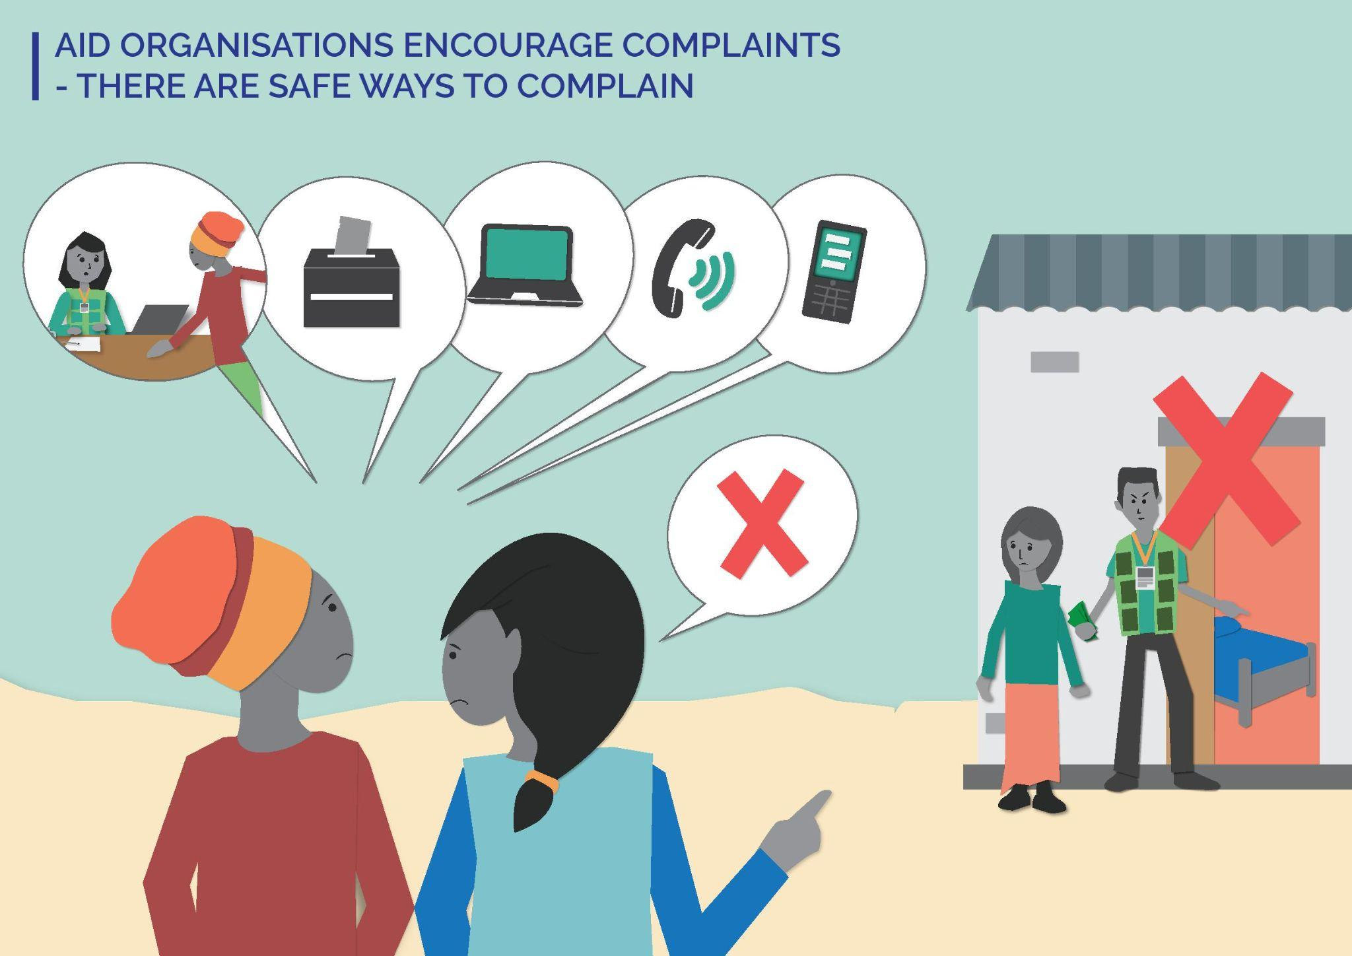
KEY MESSAGES TO SHARE IN THIS LESSON:
- Everyone has the right to report a Safeguarding complaint to [YOUR ORGANIZATION].
- [YOUR ORGANIZATION] manages complaints in a safe and confidential way. [YOUR ORGANIZATION] will work with the person who raised the complaint to make sure they are safe.
- No one will be mistreated for raising a complaint. [YOUR COMPLAINT] will protect you and it will not impact your engagement with [YOUR ORGANIZATION].
MATERIALS YOU WILL NEED FOR THIS SESSION:
- Pens, pencils/markers (different colours)
- Flipchart paper to draw/write on

Step 1
2 minutes
Introduce yourself as the facilitator and why you are facilitating this lesson:
- Let everyone know we will be talking about sensitive topics. Tell them that as facilitator, you will try to manage this conversation sensitively and safely, but if they find anything upsetting, they can take a break (e.g. step outside/get some water) and can speak to you afterwards if they want to.
- Remind everyone to treat each other with respect and care during the lesson. If there is particular language used about support or care in the community you are working on – reference this here.
Introduce Safeguarding at [YOUR ORGANIZATION]:
- Safeguarding is [YOUR ORGANIZATION] commitment to protecting program participants and community members from any form of harm caused by [YOUR ORGANIZATION].
- Safeguarding applies to all program participants and community members: children, women and men, people with disabilities. It applies to EVERYONE!

Step 2
10 minutes
Introduce the lesson for today – Aid organizations encourage complaints - There are safe ways to complain

Activity Option 1:
- Put participants in groups of four/ five people. Give them pens/markers and large sheets of paper. Ask them to draw or write what they think happens when someone makes a complaint to [YOUR ORGANIZATION]. You can ask prompting questions like:
- What do you think happens inside [YOUR ORGANIZATION]?
- Who do you think is involved in addressing the complaint?
- Go round to the different groups and ask them to explain their drawing/writing.
- Then draw or write on a piece of paper to show them what actually happens when a report is raised so they know: who is involved, how confidentiality is maintained, and how [YOUR ORGANIZATION] supports people who raise a complaint.
Note to Facilitator: To learn more about [YOUR ORGANIZATION] community reporting approach, visit [LINK TO SOURCE].

Activity Option 2:
- Put participants into three groups – one group represents children, one group represents older people, and one group represents people with disabilities. In each group, they will discuss why it may be hard for that group to raise a complaint to [YOUR ORGANIZATION].
- Give them five minutes to discuss and then ask them to present this to the wider group.
- As a wider group, discuss what can be done to enable these different groups to report complaints.
- You can ask questions like:
  - What can the community do to let people in these groups know that they can raise a complaint and will be protected?
  - What can [YOUR ORGANIZATION] do to let people in these groups know that they will not be harmed for raising a complaint, and it will not affect their engagement with [YOUR ORGANIZATION]?

Step 3
3 minutes
Remind everyone that:
- Assistance is Always Free.
- [YOUR ORGANIZATION] staff should always treat you with care and respect.
- Everyone should be able to raise a complaint and [YOUR ORGANIZATION] will make sure there are safe ways to report.
- People who raise complaints will be protected. If someone raises a complaint, it will not impact their engagement with [YOUR ORGANIZATION].
- If you have any concerns about the behaviour of a [YOUR ORGANIZATION] staff, you should report it to the Safeguarding Focal Point or [insert list of feedback channels available in that community].

Close the lesson: If it has been a difficult discussion, take time to check everyone is ok (e.g stay after the lesson in case anyone wants to speak) and/or do a post-training energizer so people leave feeling positive.

Tip! This lesson could be combined with any other of the Safeguarding images. It is important that everyone knows how to report and feels safe to report. After a lesson on one of the other topics, this lesson could be used as a reminder to encourage complaints and reassure people they will not be mistreated for raising a complaint.

Lesson 9: Aid Workers Must Never Harass You
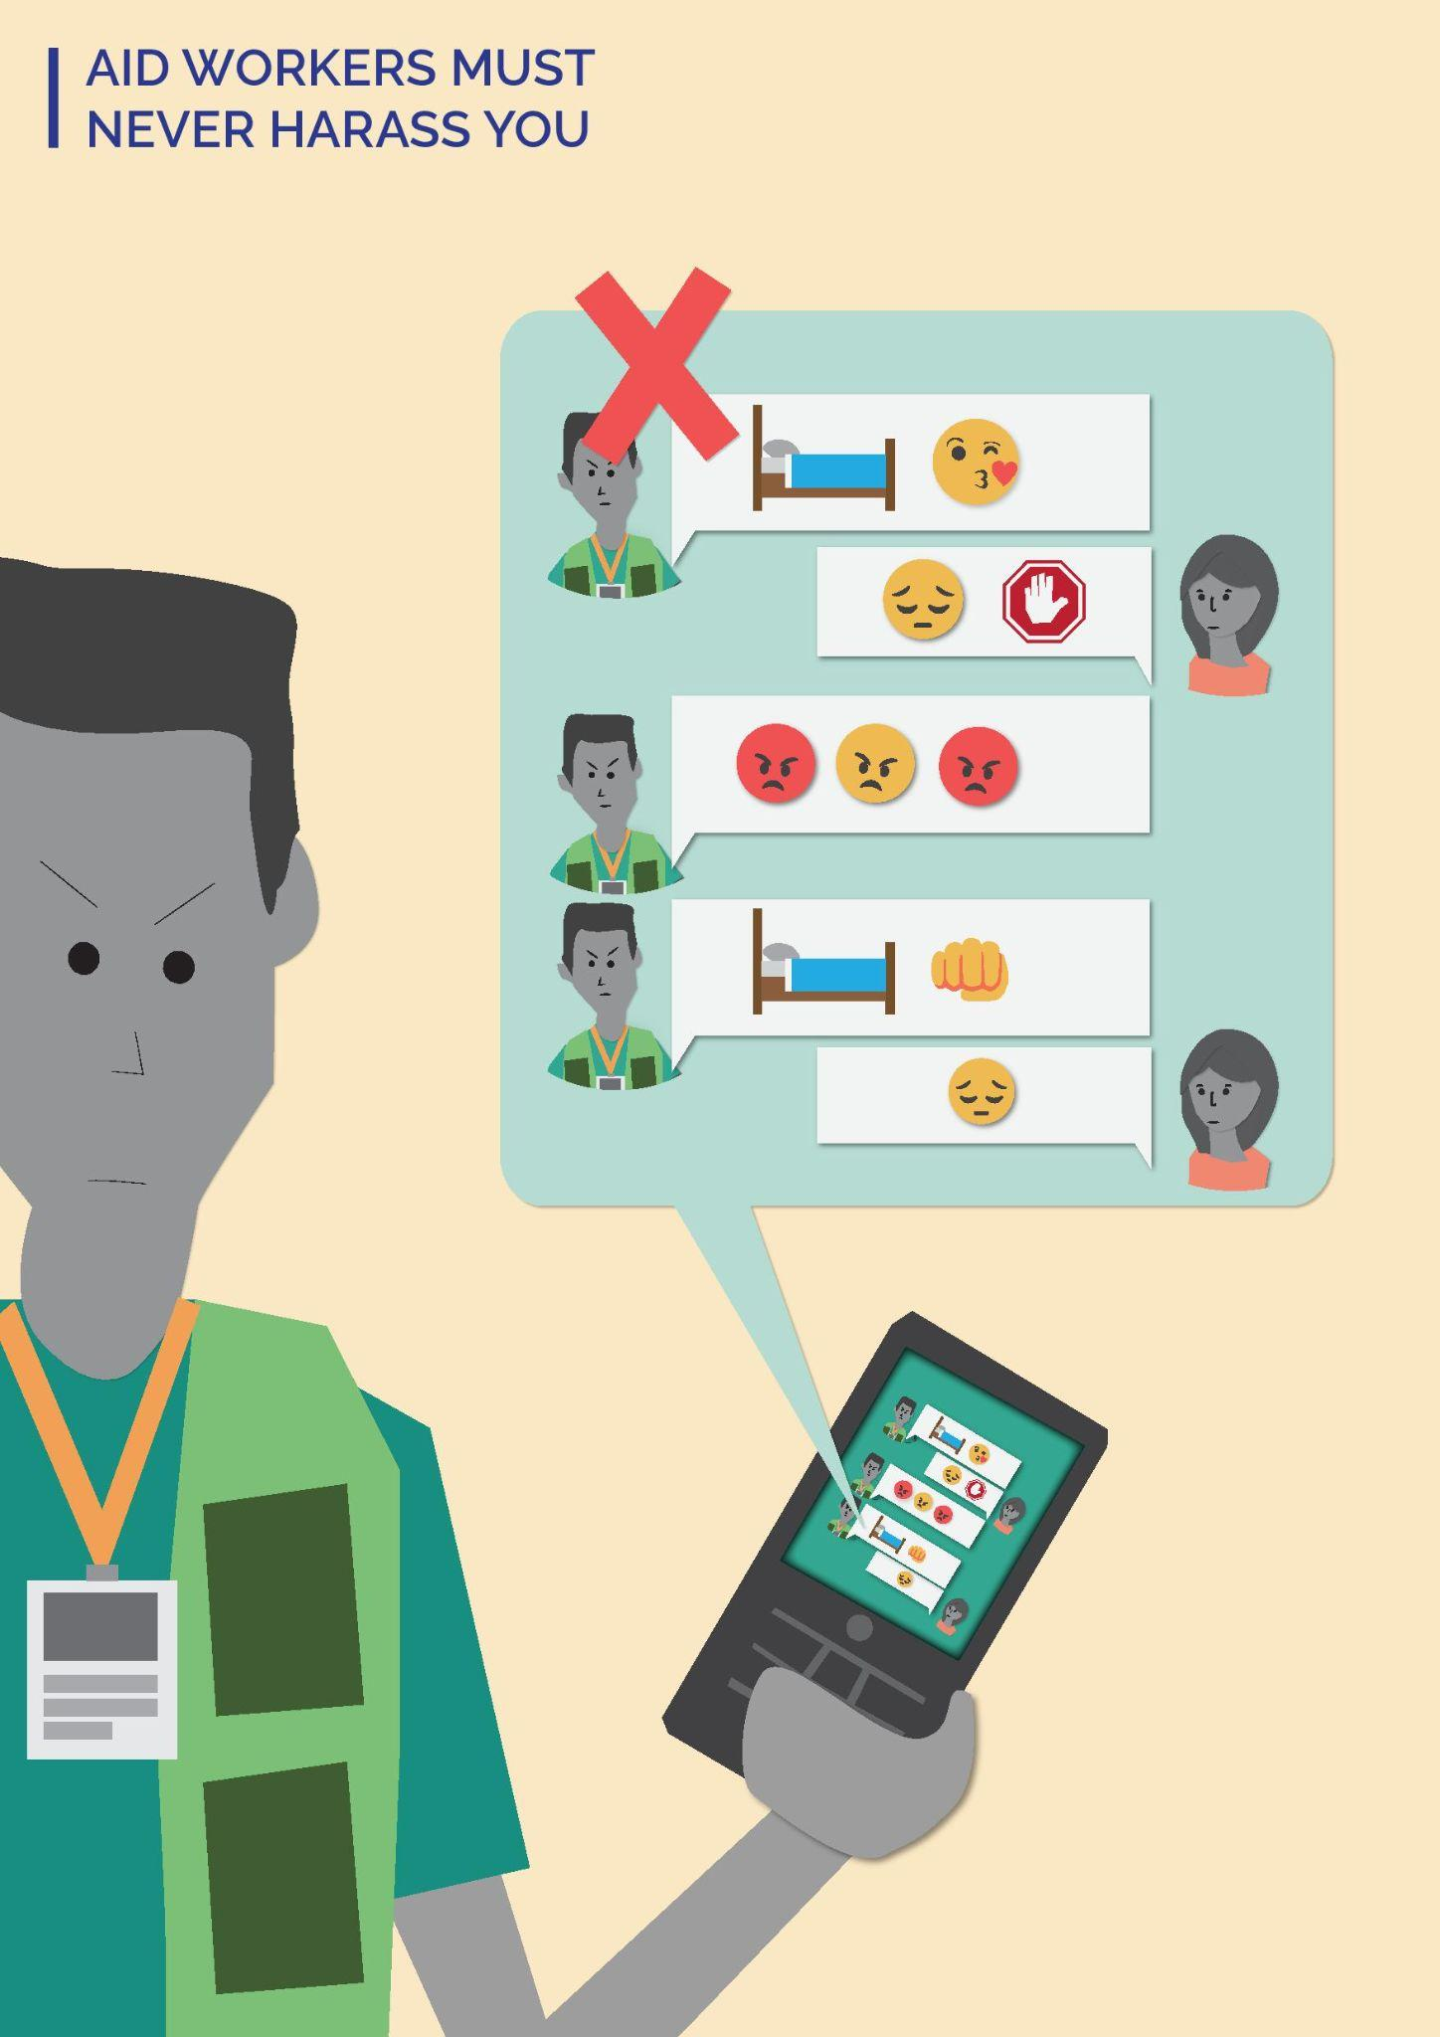
KEY MESSAGES TO SHARE IN THIS LESSON:
- [YOUR ORGANIZATION] staff should treat you with respect at all times.
- [YOUR ORGANIZATION] staff must never harass you.
- [YOUR ORGANIZATION] staff must never behave in a way that makes you feel uncomfortable or unsafe.
- If you have complaints about any [YOUR ORGANIZATION] staff, you have the right to report it.
MATERIALS YOU WILL NEED FOR THIS SESSION:
- Pens, pencils/markers (different colours)
- Flipchart paper to draw/write on
- Laminated cards – half are smiley faces and half are frowning faces
- Laminated cards – half are green and half are red
Step 1
2 minutes
Introduce yourself as the facilitator and why you are facilitating this lesson:
- Let everyone know we will be talking about sensitive topics. Tell them that as facilitator, you will try to manage this conversation sensitively and safely, but if they find anything upsetting, they can take a break (e.g. step outside/get some water) and can speak to you afterwards if they want to.
- Remind everyone to treat each other with respect and care during the lesson. If there is particular language used about support or care in the community you are working on – reference this here.
Introduce Safeguarding at [YOUR ORGANIZATION]:
- Safeguarding is [YOUR ORGANIZATION] commitment to protecting program participants and community members from any form of harm caused by [YOUR ORGANIZATION].
- Safeguarding applies to all program participants and community members: children, women and men, people with disabilities. It applies to EVERYONE!

Step 2
10 minutes
Introduce the lesson for today – Aid workers must never harass you.

Start by explaining how FH defines harassment – behaviour that humiliates or offends someone and creates an unsafe environment.

Activity option 1:
Hand out round cards with a smiley face and a frowning face on them. Every participant gets one of each card.
Read out six statements one by one. For each statement, ask them if they think this behaviour is “acceptable” or “not acceptable” by putting up the smiley face card for “acceptable” and the frowning face card for “not acceptable.” If the face image is not culturally relevant/appropriate, you could use a green card for “acceptable” and a red card for “not acceptable” instead. If red has negative connotations, use a neutral colour or image instead.
Six statements:
- An [YOUR ORGANIZATION] staff says hello and asks how my family is doing. [Acceptable]
- When [YOUR ORGANIZATION] staff speak at a community meeting, they explain how they should behave towards us and what to do if we have any complaints about [YOUR ORGANIZATION] staff behaviour. [Acceptable]
- An [YOUR ORGANIZATION] staff sends me text messages [insert relevant communication method here] late at night and asks me if I am married. [Not Acceptable]
- I often see an [YOUR ORGANIZATION] staff in [insert local area name (e.g. a village)] in the evenings. I think they are coming to drink/party/have fun [insert as culturally appropriate]. [Not Acceptable]
- I see an [YOUR ORGANIZATION] staff work with women in the community to make sure they are included in decision making. [Acceptable]
- Two [YOUR ORGANIZATION] staff lead a lesson on [insert topic from main lesson (e.g. about WASH)]. They laugh at the way a community member speaks during the lesson. [Not Acceptable]

Activity option 2:
Put the participants into groups of four/five. Hand out 2 large sheets of paper per group. Ask participants to draw two drawings:
- Draw a scenario where people feel safe.
- Draw a scenario where people do not feel safe.

At the end, get everyone to move around the room. Ask each group to explain their two drawings and the discussions they had. If they have not connected this to engagement with [YOUR ORGANIZATION], you can ask questions like:
- What behaviour is expected of [YOUR ORGANIZATION] staff?
- Do you think [YOUR ORGANIZATION] staff have a responsibility to make people safe and not carry out harm?

Participants will have different ideas of safety and what makes them feel safe. If participants share solutions that are not in line with [YOUR ORGANIZATION] values (e.g. weapons, armed groups) then respectfully challenge this and re-direct the discussion to community safety nets and what makes people feel safe (e.g. the absence of rights violations, accountability and justice mechanisms).
Remind everyone of their right to feel safe, the behaviour they should expect from [YOUR ORGANIZATION] staff, and how to report if they have complaints.

Step 3
3 minutes
Remind everyone that:
- Assistance is Always Free.
- [YOUR ORGANIZATION] staff should always treat you with care and respect.
- [YOUR ORGANIZATION] staff must never harass program participants and community members or behave in a way that makes you feel unsafe.
- Everyone should be able to raise a complaint and [YOUR ORGANIZATION] will make sure there are safe ways to report.
- If you have any concerns about the behaviour of a [YOUR ORGANIZATION] staff, you should report it to the Safeguarding Focal Point or [insert list of feedback channels available in that community].

Close the lesson: If it has been a difficult discussion, take time to check everyone is ok (e.g. stay after the lesson in case anyone wants to speak) and/or do a post-training energizer so people leave feeling positive.

Tip! This lesson could be combined with any other lessons. It is important that everyone knows how they should be treated by [YOUR ORGANIZATION] staff. You could also use it before Lesson 10 or 11, as these are sensitive topics and this image could be a good way into those discussions.

Lesson 10: Aid Workers Must Never Exchange Aid for Sex
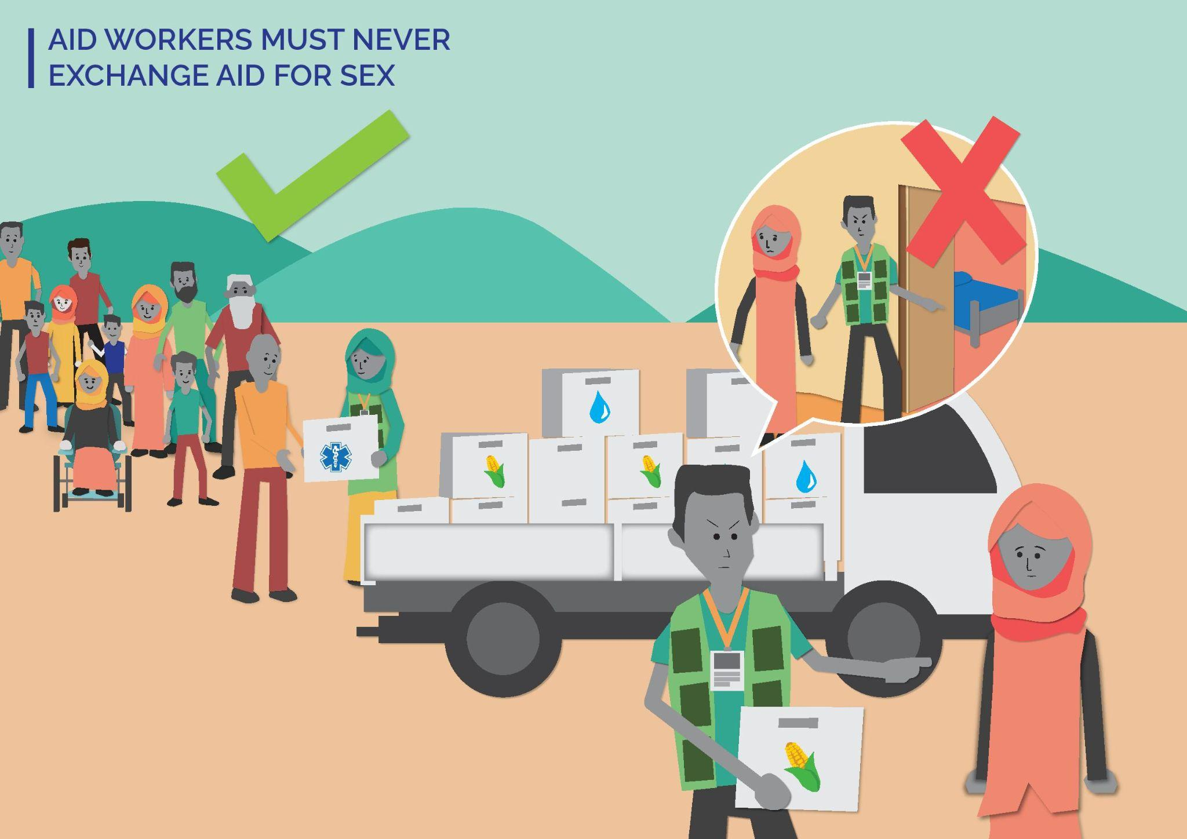
KEY MESSAGES TO SHARE IN THIS LESSON:
- Assistance is always free. You never have to exchange anything to get aid/assistance from [YOUR ORGANIZATION].
- [YOUR ORGANIZATION] staff must always treat program participants and community members with respect.
- Asking someone to exchange sex for aid is a violation of human rights. [YOUR ORGANIZATION] prohibits this.
- [YOUR ORGANIZATION] staff must not ask you to exchange sex for aid.
MATERIALS YOU WILL NEED FOR THIS SESSION:
- Pens, pencils/markers (different colours)
- Flipchart paper to draw/write on

Step 1
2 minutes
Introduce yourself as the facilitator and why you are facilitating this lesson:
- Let everyone know we will be talking about sensitive topics. Tell them that as facilitator, you will try to manage this conversation sensitively and safely, but if they find anything upsetting, they can take a break (e.g. step outside/get some water) and can speak to you afterwards if they want to.
- Remind everyone to treat each other with respect and care during the lesson. If there is particular language used about support or care in the community you are working on – reference this here.
Introduce Safeguarding at [YOUR ORGANIZATION]:
- Safeguarding is [YOUR ORGANIZATION] commitment to protecting program participants and community members from any form of harm caused by [YOUR ORGANIZATION].
- Safeguarding applies to all program participants and community members: children, women and men, people with disabilities. It applies to EVERYONE!

Step 2
10 minutes
Introduce the lesson for today – Aid Workers Must Never Exchange Aid for Sex

Activity option 1:
In the space you are in, put pens/ markers on the floor to represent three areas or ask three people to represent three areas. Area 1= this is ok. Area 2 = this is not ok but I would not report to FH. Area 3 = this is not ok and I would report to FH. Read out statements and ask participants to stand in the area they agree with (e.g. if they think a scenario is “ok,” they would move to stand in that area/by that person).
Scenarios:
- An [YOUR ORGANIZATION] staff helps me carry some heavy shopping back to my home. [Acceptable – but outline how this could become a problem. For example, if they then return to the person’s home to harass them.]
- An [YOUR ORGANIZATION] staff tells me they like my outfit. [Acceptable – but outline how this could become a problem. For example, if they continually comment on my clothing/look and this becomes sexual harassment.]
- An [YOUR ORGANIZATION] staff asks me out on a date [insert culturally appropriate action here if the language of dating is not used/appropriate]. [Unacceptable and should be reported]
- An [YOUR ORGANIZATION] staff tells me I can receive aid if I give them a hug. [Unacceptable and should be reported]
- An [YOUR ORGANIZATION] staff tells me I can receive aid only if I have sex with them. [Unacceptable and should be reported]
Outline [YOUR ORGANIZATION] Safeguarding approach. [YOUR ORGANIZATION] staff cannot ask program participants and/or community members to exchange aid for sex because this is a violation of their human rights. [YOUR ORGANIZATION] is committed to treating everyone in an equal and fair way. Any aid/engagement with [YOUR ORGANIZATION] is free. Program participants and community members do not have to exchange anything.
Ask them if they would change where they are standing because of this new information. If they do not change – tell them it is ok. Ask them:
- What would make it easier for them to raise a concern to [YOUR ORGANIZATION]?

Activity option 2:
Talk about [YOUR ORGANIZATION] Safeguarding approach. [YOUR ORGANIZATION] staff cannot ask people to exchange aid for sex because this is a violation of their human rights. [YOUR ORGANIZATION] is committed to treating everyone in an equal and fair way. Any aid/involvement with [YOUR ORGANIZATION] is free. Program participants and community members do not have to exchange anything.
- Put the participants into groups of four/five.
- Hand out a large sheet of paper per group. Ask participants to draw a poster for their community. The poster should explain that [YOUR ORGANIZATION] staff cannot exchange sex for aid.
- At the end, get everyone to move around the room and ask each group to explain their poster.

Tip! After the lesson, you can use these posters in the community to highlight community rights and [YOUR ORGANIZATION] Safeguarding approach.

Step 3
3 minutes
Remind everyone that:
- Assistance is Always Free.
- [YOUR ORGANIZATION] staff should always treat you with care and respect.
- [YOUR ORGANIZATION] staff should never ask you to exchange sex for aid. This is a violation of your rights. If this happens you should report it.
- Everyone should be able to raise a complaint and [YOUR ORGANIZATION] will make sure there are safe ways to report.
- If you have any concerns about the behaviour of a [YOUR ORGANIZATION] staff, you should report it to the Safeguarding Focal Point or [insert list of feedback channels available in that community].

Close the lesson: If it has been a difficult discussion, take time to check everyone is ok (e.g stay after the lesson in case anyone wants to speak) and/or do a post-training energizer so people leave feeling positive.

Tip! This lesson could be combined with Lessons 4, 6, or 11. You could combine these to discuss the prohibitions on sexual relationships between community members and [YOUR ORGANIZATION] staff, and as a reminder about [YOUR ORGANIZATION] commitment to treating everyone with respect.

Lesson 11: Aid Workers Must Never Exchange Sex for Employment
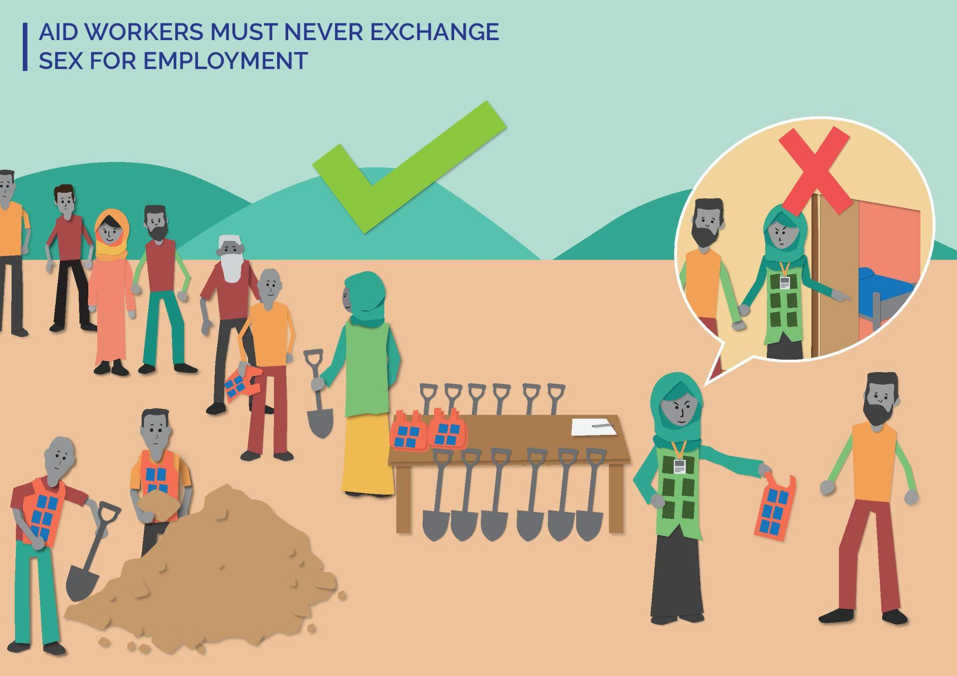
KEY MESSAGES TO SHARE IN THIS LESSON:
- [YOUR ORGANIZATION] staff must always treat you and all community members and program participants with respect.
- Asking someone to exchange sex for employment is a violation of your human rights. [YOUR ORGANIZATION] staff must not ask you to exchange sex for employment.
MATERIALS YOU WILL NEED FOR THIS SESSION:
- Laminated cards – half are smiley faces and half are frowning faces
- Laminated cards – half are green and half are red

Step 1
2 minutes
Introduce yourself as the facilitator and why you are facilitating this lesson:
- Let everyone know we will be talking about sensitive topics. Tell them that as facilitator, you will try to manage this conversation sensitively and safely, but if they find anything upsetting, they can take a break (e.g. step outside/get some water) and can speak to you afterwards if they want to.
- Remind everyone to treat each other with respect and care during the lesson. If there is particular language used about support or care in the community you are working on – reference this here.
Introduce Safeguarding at [YOUR ORGANIZATION]:
- Safeguarding is [YOUR ORGANIZATION] commitment to protecting program participants and community members from any form of harm caused by [YOUR ORGANIZATION].
- Safeguarding applies to all program participants and community members: children, women and men, people with disabilities. It applies to EVERYONE!

Step 2
10 minutes
Introduce the lesson for today – Aid Workers Must Never Exchange Sex for employment

Activity option 1:
Two [YOUR ORGANIZATION] staff perform two role plays about exchanging sex for employment. One [YOUR ORGANIZATION] staff plays a community member; the other plays an [YOUR ORGANIZATION] staff.
- Role Play 1: Show the [YOUR ORGANIZATION] staff telling a community member about a new job at FH [make the job relevant to the main lesson e.g. about WASH]. They tell the community member they can get them the job if the community member has sex with them [use culturally appropriate language here (e.g. a euphemism that people will understand means sex, such as ‘be nice to me)]. The community member says “no,” and then tells another [YOUR ORGANIZATION] staff what happened.
After the role play – open it up to discussion with the participants.
- What did they think of the [YOUR ORGANIZATION] staff behaviour?
- What is positive about the community member’s response?

- Role Play 2: Show an [YOUR ORGANIZATION] staff telling a community member about a new job at [YOUR ORGANIZATION] [make the job relevant to the main lesson (e.g. about WASH), but different to the first role play]. They tell the community member about what the job will involve. The community member asks questions about how they can apply and the [YOUR ORGANIZATION] staff gives correct information about [YOUR ORGANIZATION] recruitment process.
After the role play – open it up to discussion with the participants.
- What did they think of the [YOUR ORGANIZATION] staff behaviour here?
- What was positive about this approach?

Talk to the participants about [YOUR ORGANIZATION] commitment to equality and fairness (e.g. that it is not ok for [YOUR ORGANIZATION] staff to try to exchange a job for sex). [YOUR ORGANIZATION] has a fair and equitable approach to employment. Emphasize that [YOUR ORGANIZATION] staff cannot ask for bribes or sex for employment because this is exploitation.

Activity option 2:
Hand out round cards with a smiley face and a frowning face on them. Every participant gets one of each card.
Read out four scenarios one by one. For each statement, ask participants if they think this is “ok” or “not ok” by putting up the smiley face card for “ok” and the frowning face card for “not ok”. If the face image is not culturally relevant/appropriate, you could use a green card for “ok” and a red card for “not ok” instead.
Four scenarios:
- You hear that a community member has got a job at [YOUR ORGANIZATION] because they are in a relationship with a senior staff. [Not ok]
- Your friend applies for a job at [YOUR ORGANIZATION] as an [change as relevant for community/context or amend depending on the topic of the main lesson]. They offer to have a sexual relationship with the [YOUR ORGANIZATION] staff, but the staff refuses. They explain that relationships between staff and community members is prohibited and employment is not conditional on sex. [Ok]
- You decide to apply for a job with [YOUR ORGANIZATION] as an [change as relevant for community/context and amend depending on the topic of the main lesson]. You are nervous, so an [YOUR ORGANIZATION] staff offers to give you the interview questions in advance if you have sex with them [insert language about sex that is appropriate in the community/context you are working in]. [Not ok]
- [YOUR ORGANIZATION] is advertising two new jobs. They advertise this in [insert the way in which information is shared with the whole community, as relevant for this community/context] and remind everyone that anyone can apply. You don’t have to exchange anything, including sex, to get the job. [Ok]

Talk to the participants about [YOUR ORGANIZATION] commitment to equality and fairness (e.g. that it is not ok for [YOUR ORGANIZATION] staff to try to exchange a job for sex or a bribe). [YOUR ORGANIZATION] has a fair and equitable approach to employment. Emphasize that [YOUR ORGANIZATION] staff cannot ask for bribes or sex for employment because this is exploitation.

Step 3
3 minutes
Remind everyone that:
- Assistance is Always Free.
- [YOUR ORGANIZATION] staff should always treat you with care and respect.
- [YOUR ORGANIZATION] staff should never ask you to exchange sex for employment. This is a violation of your rights. If this happens, you should report it.
- Everyone should be able to raise a complaint and [YOUR ORGANIZATION] will make sure there are safe ways to report it.
- If you have any concerns about the behaviour of a [YOUR ORGANIZATION] staff, you should report it to the Safeguarding Focal Point or [insert list of feedback channels available in that community].

Close the lesson: If it has been a difficult discussion, take time to check everyone is ok (e.g. stay after the lesson in case anyone wants to speak) and/or do a post-training energizer, so people leave feeling positive.

Tip! This lesson could be combined with Lessons 4, 6, or 10. You could combine these to discuss the prohibitions on sexual relationships between community members and [YOUR ORGANIZATION] staff, and as a reminder about [YOUR ORGANIZATION] commitment to treating everyone with respect.

The Community Based Safeguarding Visual Toolkit was created as a resource for agencies to utilize as a visual means of communicating with impacted communities on key safeguarding messages. It is to support communities in realizing their rights in regard to protection aganist sexual exploitation, abuse and harassment, and promote a ‘speak up’ culture.

